**Table of Contents**

**Abstract** 3

**Keywords:** 3

**1.** **Introduction** 3

**2.** **Methodology** 4

**2.1. Data Source and Type of Study** 4

**Figure 1.** Methodology for bibliometric study of the scientific documents in corn nixtamalization 4

**2.2. Bibliometric Analysis and Indicators** 5

**3.** **Results and Discussion** 5

**3.1** **Yearly research development and trend of corn nixtamalization** 5

**Figure 2.** Cumulative publications of documents on a year-on-year basis from 2010-2023 5

**3.2** **Collaboration analysis per country** 6

**Table 1.** Top countries that published with three documents in Scopus 6

**Figure 3.** Citation-country cooperation network on corn nixtamalization from Scopus database. (Out of 41 countries searched, 15 countries that published at least three documents were considered.) 7

**Table 2.** Top countries that published with three documents in WOS 7

**Figure 4.** Citation-country cooperation network on corn nixtamalization from WOS database. (Out of 43 countries searched, 16 countries that published at least three documents were considered.) 8

**3.3** **Collaboration analysis per organization** 9

**Table 3.** Top organization that published at least 3 documents in Scopus 9

**Figure 5.** Citation-organization cooperation network on corn nixtamalization from Scopus database. (Out of 1010 organization searched, 4 organization that published at least three documents were considered.) 10

**Table 4.** Top organization that published more than 9 documents in WOS 10

**Figure 6.** Citation-organization cooperation network on corn nixtamalization from WOS database. (Out of 379 organization searched, 9 organization that published at least nine documents were considered.) 11

**3.4** **Authors and citation relationship** 11

**Table 5.** Most productive authors that published more than 8 documents in Scopus 11

**Figure 7.** Citation-author cooperation network on corn nixtamalization from Scopus database. (Out of 1157 authors searched, 23 authors that published at least eight documents were considered.) 13

**Figure 8.** Citation-author cooperation network on corn nixtamalization from Scopus database. (23 authors that published at least eight documents, 2 authors with no research collaboration forms a separate cluster) 13

**Table 6.** Most productive authors that published more than 8 documents in WOS 14

**Figure 9.** Citation-author cooperation network on corn nixtamalization from WOS database. (Out of 1324 authors searched, 19 authors that published at least eight documents were considered.) 15

**3.5** **Documents and citation relationship** 15

**Table 7.** Top documents that have been cited for at least 40 times in Scopus 15

**Figure 10.** Citation-document cooperation network on corn nixtamalization from Scopus database. (Out of 364 documents searched, 17 documents have been cited for at least 40 times were considered.) 17

**Table 8.** Top documents that have been cited for at least 40 times in WOS 18

**Figure 11.** Citation-document cooperation network on corn nixtamalization from WOS database. (Out of 370 documents searched, 18 documents have been cited for at least 40 times were considered.) 19

**3.6** **Most productive journals in corn nixtamalization** 19

**Table 9.** Top journal sources where more than five documents were published from Scopus 20

**Figure 12.** Citation-sources cooperation network on corn nixtamalization from Scopus database. (Out of 146 sources searched, 19 documents have been cited for at least five documents were considered.) 21

**Figure 13.** Citation-sources cooperation network on corn nixtamalization from Scopus database. (19 sources with at least five documents, 2 sources with no research collaboration forms each separate cluster) 22

**Table 10.** Top journal sources where more than five documents were published from WOS 22

**Figure 14.** Citation-sources cooperation network on corn nixtamalization from WOS database. (Out of 134 sources searched, 18 documents have been cited for at least five documents were considered.) 23

**3.7** **Network visualization of corn nixtamalization based on keywords** 24

**Figure 15.** Co-occurrence-keywords cooperation network visualization with five as the minimum number of occurrences of a keyword in Scopus 24

**Figure 16.** Co-occurrence-keywords cooperation network visualization with five as the minimum number of occurrences of a keyword in WOS 25

**3.8** **Density visualization of corn nixtamalization based on text data** 26

**Figure 17.** Density visualization with ten as the minimum number of occurrences of a term in merged Scopus and WOS titles and abstracts 27

**Table 11.** List of relevant journals related to starch 27

**4.** **Conclusion** 28

**Acknowledgements** 29

**Credit authorship contribution statement** 29

**References** 29

**A Bibliometric Analysis of Corn Nixtamalization from Scopus and Web of Science Databases using VOSviewer**

Lady Shernalyn P. Cadavero1, Clarissa B. Juanico2. Aldrin P. Bonto1

1Chemistry Department, De La Salle University, 2410 Taft, Avenue, Manila 0922, Philippines

2Institute of Human Nutrition and Food, College of Human Ecology, University of the Philippines Los Baños, College, Laguna, Philippines

# **Abstract**

Corn based food products are prepared by nixtamalization by treating maize grains with lime solution to obtain “nixtamal.” Research documents in corn nixtamalization exponentially increased last 2013 in other developed countries. In this review, we collected scientific documents related to corn nixtamalization from Scopus and Web of Science, the two main bibliographic databases were analyzed on VOSviewer 1.6.19 for annual publication trend, countries, organizations, contributing authors, journals, sources, and keywords. With a total of 364 from Scopus and 370 in Web of Science, Mexico was identified with the most productive country and organization because corn has been the main staple in Mexican traditional food for many years. Results showed that Ramírez-Wong, Benjamin is the most productive author in Scopus while Santiago-Ramos, David in Web of Science. From both databases between 2010 to 2023, Nuss & Tanumihardjo, 2010 is the most cited document while Journal of Cereal Science journal source where most of the researchers prefer to publish. From the 441 journals of merged Scopus-WOS databases, starch is one of the relevant terms commonly appear in the title and abstract. This review can help researchers to have consideration in utilizing further development in the study of corn nixtamalization.

**Keywords:** Nixtamalization; Corn; Bibliometric; VOSviewer; Scopus; WOS

# **Introduction**

*Zea mays L.,* known as corn or maize, is the world's vital annual cereal crop that sources carbohydrates, fats, protein, dietary fiber, vitamins, and health-related phytochemical compounds (Rouf Shah et al., 2016). Corn is classified by its color and kernel configuration—yellow, white, dent, or flint—and includes regular food-grade yellow and white corn, specialty corn like quality protein maize (QPM), waxy, high-amylose, high-oil, blue, popcorn, sweet maize, and Cuzco corn (Rooney & Serna-Saldivar, 2015). Moreover, it was one of Mesoamerica's main crops and Mexico's most widely grown and consumed cereal, used to make masa and other corn-based products like tamales, tostadas, atole, tejuino, pinole, corn chips, and taco shells (Valderrama Bravo et al., 2020). Among the corn-based products, tortillas are the most utilized ingredient to prepare various Mexican and Central American dishes in rural and urban areas. Maize tortillas made from traditional masa harina or "dough flour" are the oldest variety of tortillas, the most studied maize food from the preparation process to dietary properties (Menchaca-Armenta et al., 2023). Tortillas are made by cooking whole maize in calcium hydroxide-containing water, steeping to anneal the starch granules, removing the excess cooking liquor called nejayote, washing the kernel, and grinding to masa (Chaidez-Laguna et al., 2016). The process necessitates the use of an alkaline or lime solution to weaken the cell walls, allowing the removal of the pericarp and the solubilization of cell walls in the peripheral endosperm, causing swelling and reorganization of starch granules at temperatures above glass transition but below gelatinization, allowing the modification of the physical properties of starch and protein (Carrera et al., 2015). As a result, nixtamalization improves the nutritional value, calcium and iron bioavailability, and physicochemical, thermal, and rheological properties of nixtamal, reduces mycotoxin and produces a significant amount of resistant starch, which promotes health due to its prebiotic effects (Hernandez et al., 2022; Serna-Saldivar, 2021).

Corn nixtamalization is widely investigated in the academe and food industry. Exploring this method with other corn varieties is a good strategy for introducing new commodities globally. Despite the comprehensive reviews regarding nixtamalized corn (Santiago-Ramos, Figueroa-Cárdenas, et al., 2018; Serna-Saldivar, 2021), there is still a lack of bibliometric analysis of scientific works published on this topic. Only few have done bibliometric mapping analysis mainly related to corn (Feng et al., 2022; Liu et al., 2021; Montoya et al., 2020; Santillán‐fernández et al., 2021; Ying & Jin, 2022; Yuan & Sun, 2020). Bibliometric methods utilize analysis and knowledge mapping to quantify literature evaluation which sorts of citations, authorships, keywords, and methodology (Fasogbon & Adebo, 2022). Hence, this study aims to use the bibliometric method to collect documents related to nixtamalized corn from Scopus and the Web of Science databases, then analyze the categories such as countries, organizations, authors, journals, sources, and keywords using the VOSviewer application. Scopus and WOS are the two largest bibliographic data source that provides scientometric indicators to evaluate citation count and performance of the researchers (Pranckutė, 2021).

# **Methodology**

## **2.1. Data Source and Type of Study**

The data in this study was analyzed using bibliometric analysis carried out by retrieving publications from Scopus and Web of Science databases with the date of access on January 28, 2023. The search parameters with the Boolean syntax used are (TITLE-ABS-KEY ("nixtamaliz*") AND TITLE-ABS-KEY ("corn" OR "maize")) in the period between 2010 to 2023. The author, title source, publication year, and other information were exported in *.ciw and *csv formats, then imported to VOSviewer (version 1.6.19) to create a map based on bibliometric. The total number of documents obtained from Scopus and WOS are 364 and 370, respectively. The csv files from two databases are saved to xlsx format to combine into one worksheet using Append Query in Microsoft Excel 2021 program and filtered using Conditional Formatting. The Preferred Reporting Items for Systematic Reviews and Meta-Analyses (PRISMA) method (Page et al., 2021) was used for merging Scopus and WOS databases to create a map based on text data of the title and abstract. The total number of documents for Scopus, WOS, and Scopus-WOS are 123, 129, and 241, respectively. After the removal of duplicates, records of documents were reduced to 441. In addition, all source-type documents, and language are considered. Obtained data are tabulated, and the representations are applied through tables and graphs.

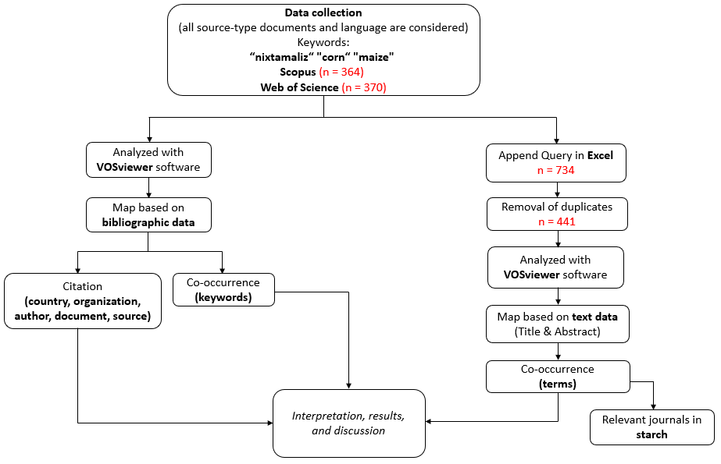

### **Figure 1.** Methodology for bibliometric study of the scientific documents in corn nixtamalization

In VOSviewer, bibliographic map only contains one type of items where items are considered as object of interest such as countries, organizations, authors, documents, and sources connected by only one type of link. Nodes is sometimes used instead an item in other software tools. Set of items called clusters while set of items with links is called network. Items contains weight and score attributes therefore a higher weight is more important than with a lower weight used in both network and density visualization. On the other hand, score attributes are only applicable in overlay visualization. Links and Total Link Strength (TLS) are two standard weight attributes. Links are the number of links on an item with other items while TLS is the total strength of the links of an item with other items (Jan van Eck & Waltman, 2023).

## **2.2. Bibliometric Analysis and Indicators**

VOSviewer software was used for bibliometric analysis developed in 2009, which provides an easy-to-interpret graphical representation of bibliometric data maps. It is based on the shortest distance between nodes to identify which pair of nodes is closely related compared to the second pair of nodes (van Eck & Waltman, 2010). VOSviewer was used to organize and classify bibliometric indicators based on citation and co-occurrence of keywords through network visualization. Clustering is a supportive technique for the specific type of analysis in bibliographic mapping to create thematic or social network clusters to further understand how research field develops (Donthu et al., 2021).

# **Results and Discussion**

## **Yearly research development and trend of corn nixtamalization**

The quantity of articles published yearly gives a reliable estimate of the research trend in a particular study area. The trend in the number of publications can provide insight into the likely research trend in the near future. The research productivity on corn nixtamalization from 2010 to 2023 was shown in Figure 2 by plotting the number of Scopus and WOS-based documents and cumulative documents on a year-over-year basis. Moreover, Scopus and WOS resulted in an average of annually published papers of 26.00 and 26.43, respectively. There is evidence of a growing publication trend about nixtamalized corn after 2012, with more published articles from 2013-2019 and a peak in published works (Scopus = 41, WOS = 47) in 2020. Even though COVID-19 pandemic and lockdown occurred during 2020-2022, relatively higher papers were still published compared to previous years, indicating innovative progress in answering gaps about corn nixtamalization. Increased published journals in year 2020 relatively focuses on fortification studies that may help for nutritional deficiencies and mycotoxins to develop innovative strategies for the prevention of food contamination and human diseases.

### **Figure 2.** Cumulative publications of documents on a year-on-year basis from 2010-2023

## **Collaboration analysis per country**

Determining the country’s origin or a collaborative effort between them to produce novel information promotes the approach to research and research potentials, so 41 countries were tallied. Table 1 shows the highest 15 countries with at least 3 documents published obtained in Scopus database highlighting Mexico with 265 papers, followed by United States (57), Indonesia (17) then Spain (13). Eleven countries that published articles in the range of 3 to 6 while 26 countries that published articles in the range of 1 to 2. The total number of publications by adding the contributions from each of the countries is 427 that is relatively higher than 364 which suggests that there has been a collaborative work between those 41 countries. It is noticeable from Table 1 that out of 41 countries, there are 6 countries included in the 15 nominal GDP rank which indicates that the economically developed countries identify the development of corn processing using nixtamalization. Mexico received the greatest number of citations from 265 published journals followed by United States and Spain. However, the highest average citations per document was Brazil (43.33) followed by France (34.25) then Czech Republic (29.00) due to collaborative studies in mycotoxins.

### **Table 1.** Top countries that published with three documents in Scopus

|  |  |  |  |  |  |  |  |
| --- | --- | --- | --- | --- | --- | --- | --- |
| **#** | **Country** | **Quantity** | **Percentage (%)** | **Citation** | **Average citations per document** | **Nominal GDP Rank** | **Total link strength** |
| 1 | Mexico | 265 | 62.06 | 3145 | 11.87 | 15 | 237 |
| 2 | United States | 57 | 13.35 | 1344 | 23.58 | 1 | 152 |
| 3 | Indonesia | 17 | 3.98 | 19 | 1.12 | 17 | 1 |
| 4 | Spain | 13 | 3.04 | 152 | 11.69 | 16 | 46 |
| 5 | India | 6 | 1.41 | 10 | 1.67 | 5 | 11 |
| 6 | Nigeria | 5 | 1.17 | 29 | 5.80 | 31 | 15 |
| 7 | Colombia | 4 | 0.94 | 53 | 13.25 | 44 | 38 |
| 8 | Czech Republic | 4 | 0.94 | 116 | 29.00 | 47 | 12 |
| 9 | France | 4 | 0.94 | 137 | 34.25 | 7 | 11 |
| 10 | Philippines | 4 | 0.94 | 8 | 2.00 | 40 | 29 |
| 11 | Brazil | 3 | 0.70 | 130 | 43.33 | 12 | 5 |
| 12 | Guatemala | 3 | 0.70 | 80 | 26.67 | 70 | 18 |
| 13 | Italy | 3 | 0.70 | 73 | 24.33 | 10 | 8 |
| 14 | Netherlands | 3 | 0.70 | 30 | 10.00 | 19 | 7 |
| 15 | South Africa | 3 | 0.70 | 12 | 4.00 | 39 | 12 |
| 16 | Other 26 countries | 33 | 7.73 | 696 | 21.09 | - | - |

a Nominal GDP Rank as per the International Monetary Fund (2022 estimates), World Economic Outlook Database, October 2022.

Figure 3 indicates that Mexico has been more collaborative in other 14 countries except Brazil while

United States also has been collaborative in other countries aside Indonesia. This is supported by the Total Link Strength (TLS) shown in Table 1 that Mexico was most superior in terms of collaborative research with a TLS of 237 followed by United States with 152 while Indonesia and Brazil had the least score of 1 and 5, respectively. This attribute shows connectivity between items and contain weight properties in terms of citations (Zaib et al., 2022)

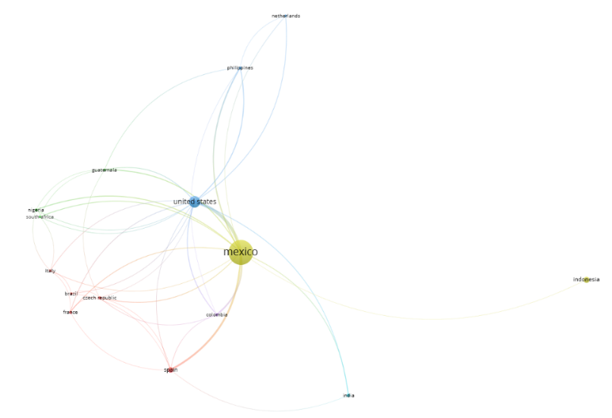

### **Figure 3.** Citation-country cooperation network on corn nixtamalization from Scopus database. (Out of 41 countries searched, 15 countries that published at least three documents were considered.)

The results of visualization of research mapping related to corn nixtamalization shows 41 items with a total of 15 countries with at least three documents published which are divided into 6 clusters in Scopus, namely:

1. Cluster 1 consists of 5 items including Brazil, Czech Republic, France, Italy, Spain
2. Cluster 2 consists of 3 items including Guatemala, Nigeria, South Africa
3. Cluster 3 consists of 3 items including Netherlands, Philippines, United States
4. Cluster 4 consists of 2 items including Indonesia, Mexico
5. Cluster 5 consists of 1 item including Colombia
6. Cluster 6 consists of 1 item including India

Compared to Scopus, Web of Science database resulted to 43 participating countries. Table 2 shows the highest 16 countries with at least 3 documents highlighting Mexico with 283 papers, followed by United States (59), Spain (12) then Indonesia (7). Thirteen countries published articles in the range of 3 to 7 while 27 other countries published in the range of 1 to 2. 443 is the total number of publications from collaborative work between 43 countries and 6 countries out of these numbers are included in the 15 nominal GDP rank. Philippines and Thailand are Asian countries that were not present between the two tables. Mexico is also the had the greatest number of citations from 283 journals followed USA and Spain. Meanwhile, Brazil is had also the highest number of average citations (45.33) followed by Czech Republic (26.25) then Guatemala (26.00). Guatemala exceeded the average citations in the record of France (25.00) that is included in the top three highest average citation in Scopus database.

### **Table 2.** Top countries that published with three documents in WOS

|  |  |  |  |  |  |  |  |
| --- | --- | --- | --- | --- | --- | --- | --- |
| **#** | **Country** | **Quantity** | **Percentage (%)** | **Citation** | **Average citations per document** | **Nominal GDP Rank** | **Total link strength** |
| 1 | Mexico | 283 | 63.88 | 3370 | 11.91 | 15 | 541 |
| 2 | USA | 59 | 13.32 | 1287 | 21.81 | 1 | 336 |
| 3 | Spain | 12 | 2.71 | 138 | 11.50 | 16 | 61 |
| 4 | Indonesia | 7 | 1.58 | 3 | 0.43 | 17 | 12 |
| 5 | France | 6 | 1.35 | 150 | 25.00 | 7 | 19 |
| 6 | Nigeria | 5 | 1.13 | 26 | 5.20 | 31 | 26 |
| 7 | Czech Republic | 4 | 0.90 | 105 | 26.25 | 47 | 32 |
| 8 | India | 4 | 0.90 | 8 | 2.00 | 5 | 19 |
| 9 | Italy | 4 | 0.90 | 88 | 22.00 | 10 | 25 |
| 10 | Netherlands | 4 | 0.90 | 31 | 7.75 | 19 | 23 |
| 11 | Thailand | 4 | 0.90 | 12 | 3.00 | 27 | 4 |
| 12 | Turkey | 4 | 0.90 | 31 | 7.75 | 20 | 52 |
| 13 | Brazil | 3 | 0.68 | 136 | 45.33 | 12 | 9 |
| 14 | Colombia | 3 | 0.68 | 48 | 16.00 | 44 | 47 |
| 15 | Guatemala | 3 | 0.68 | 78 | 26.00 | 70 | 26 |
| 16 | South Africa | 3 | 0.68 | 10 | 3.33 | 39 | 22 |
| 17 | Other 27 countries | 35 | 7.90 | 758 | 21.66 | - | - |

a Nominal GDP Rank as per the International Monetary Fund (2022 estimates), World Economic Outlook Database, October 2022.

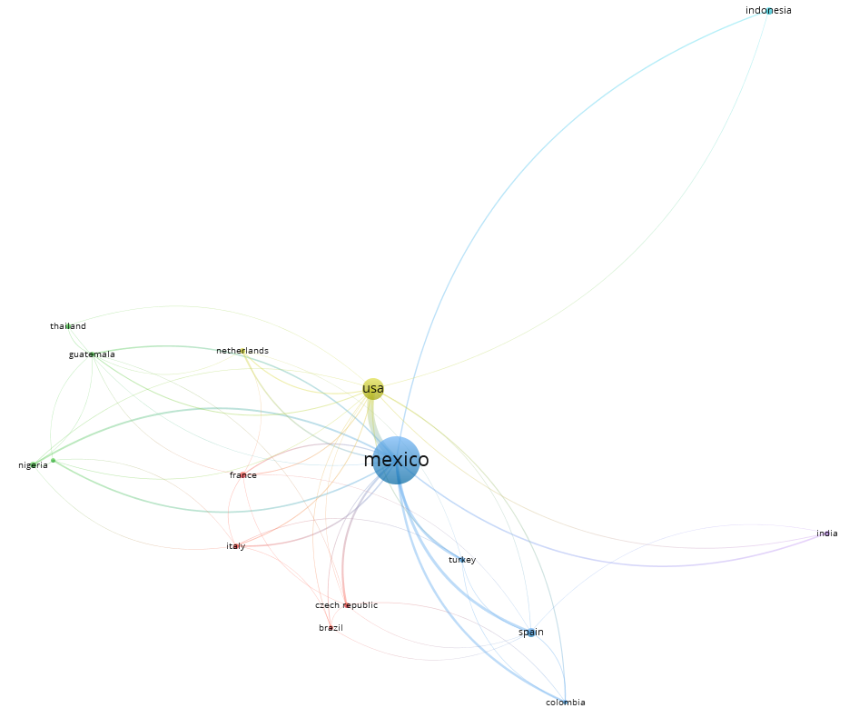

### **Figure 4.** Citation-country cooperation network on corn nixtamalization from WOS database. (Out of 43 countries searched, 16 countries that published at least three documents were considered.)

The results of visualization of research mapping related to corn nixtamalization shows 43 items with a total of 16 countries with at least three documents published which are divided into 6 clusters in WOS, namely:

1. Cluster 1 consists of 4 items including Brazil, Czech Republic, France, Italy
2. Cluster 2 consists of 4 items including Guatemala, Nigeria, South Africa, Thailand
3. Cluster 3 consists of 4 items including Colombia, Mexico, Spain, Turkey
4. Cluster 4 consists of 2 items including Netherlands, USA
5. Cluster 5 consists of 1 item including India
6. Cluster 6 consists of 1 item including Indonesia

Figure 4 indicates that both Mexico and US have been collaborative in other 14 countries with no exception.

## **Collaboration analysis per organization**

There are top 4 organizations that are identified out of 1010 organizations that meet at least 4 documents from Scopus database and three of them are from Mexico shown in Table 3. It was found that Centro de Biotecnología FEMSA, Escuela de Ingeniería y Ciencias, Tecnologico de Monterrey gathers the highest 92 citations resulted to an average citation of each document to 13.14 which was far more superior than Ceprobi, Instituto Politécnico Nacional and Departamento de Biotecnología, Universidad Autónoma Metropolitana-iztapalapa with 9.00 and 7.33, respectively.

### **Table 3.** Top organization that published at least 3 documents in Scopus

|  |  |  |  |  |  |  |  |
| --- | --- | --- | --- | --- | --- | --- | --- |
| **#** | **Organization** | **Country** | **Documents** | **Citations** | **Average citations per document** | | |
| 1 | Centro de Biotecnología FEMSA, Escuela de Ingeniería y Ciencias, Tecnologico de Monterrey | Mexico | 7 | 92 | 13.14 |  |  |
| 2 | Ceprobi, Instituto Politécnico Nacional | Mexico | 3 | 27 | 9.00 |  |  |
| 3 | Departamento de Biotecnología, Universidad Autónoma Metropolitana-iztapalapa | Mexico | 3 | 22 | 7.33 |  |  |
| 4 | Research Centre for Chemistry, Indonesian Institute of Sciences | Indonesia | 3 | 2 | 0.67 |  |  |

These Mexican organizations concluded that they are more dominant than Research Centre for Chemistry, Indonesian Institute of Sciences with average citations of 0.67. No TLS indicated in these citation-organization cooperation network as shown in Figure 5 and all of them were separated in clusters which means that none of their published documents were collaborated in each other.

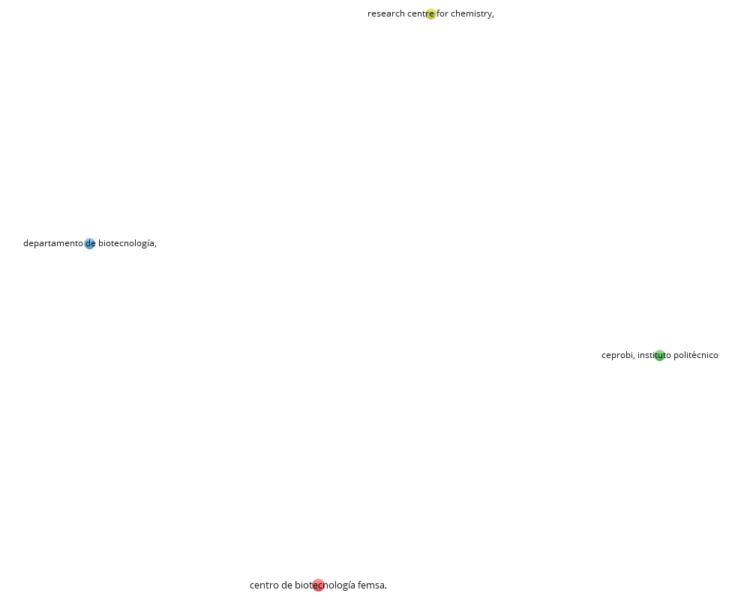

### **Figure 5.** Citation-organization cooperation network on corn nixtamalization from Scopus database. (Out of 1010 organization searched, 4 organization that published at least three documents were considered.)

In Web of Science, the bibliometric mapping analysis showed that there are top 9 organizations from Mexico out 379 organizations that are identified with at least 9 documents published shown in Table 4. In this database, IPN Instituto Politécnico Nacional had published 73 documents that gathers a total of 773 citations and the resulted average citations in each document was 10.59 however Universidad Nacional Autónoma de México and Universidad Autónoma de Sinaloa was far more superior than IPN with average citations of 18.45 and 16.32, respectively.

### **Table 4.** Top organization that published more than 9 documents in WOS

|  |  |  |  |  |  |  |  |  |  |  |  |  |  |  |  |  |  |  |  |  |  |  |  |  |  |  |  |  |  |  |  |  |  |  |  |  |  |  |  |  |  |  |  |  |  |  |  |  |  |  |  |  |  |  |  |  |  |  |  |  |  |
| --- | --- | --- | --- | --- | --- | --- | --- | --- | --- | --- | --- | --- | --- | --- | --- | --- | --- | --- | --- | --- | --- | --- | --- | --- | --- | --- | --- | --- | --- | --- | --- | --- | --- | --- | --- | --- | --- | --- | --- | --- | --- | --- | --- | --- | --- | --- | --- | --- | --- | --- | --- | --- | --- | --- | --- | --- | --- | --- | --- | --- | --- |
| |  |  |  |  |  |  | | --- | --- | --- | --- | --- | --- | | **#** | **Organization** | **Documents** | **Citations** | **Average citations per document** | **Total link strength** | | 1 | IPN Instituto Politécnico Nacional | 73 | 773 | 10.59 | 511 | | 2 | Universidad Autónoma de Querétaro | 46 | 692 | 15.04 | 402 | | 3 | Universidad Nacional Autónoma de México | 40 | 738 | 18.45 | 270 | | 4 | Universidad de Sonora | 22 | 199 | 9.05 | 135 | | 5 | Tecnológico de Monterrey | 21 | 187 | 8.90 | 213 | | 6 | Universidad Autónoma de Sinaloa | 19 | 310 | 16.32 | 133 | | 7 | INIFAP Instituto Nacional de Investigaciones Forestales Agricolas y Pecuarias | 18 | 191 | 10.61 | 146 | | 8 | Universidad Autónoma Metropolitana-iztapalapa | 17 | 178 | 10.47 | 88 | | 9 | Universidad Autónoma de Chihuahua | 10 | 115 | 11.50 | 114 | |  |

The highest resulted TLS was IPN Instituto Politécnico Nacional (511) followed by Universidad Autónoma de Querétaro (402) then Universidad Nacional Autónoma de México (270) which shows more collaborative work between organizations (Figure 6).

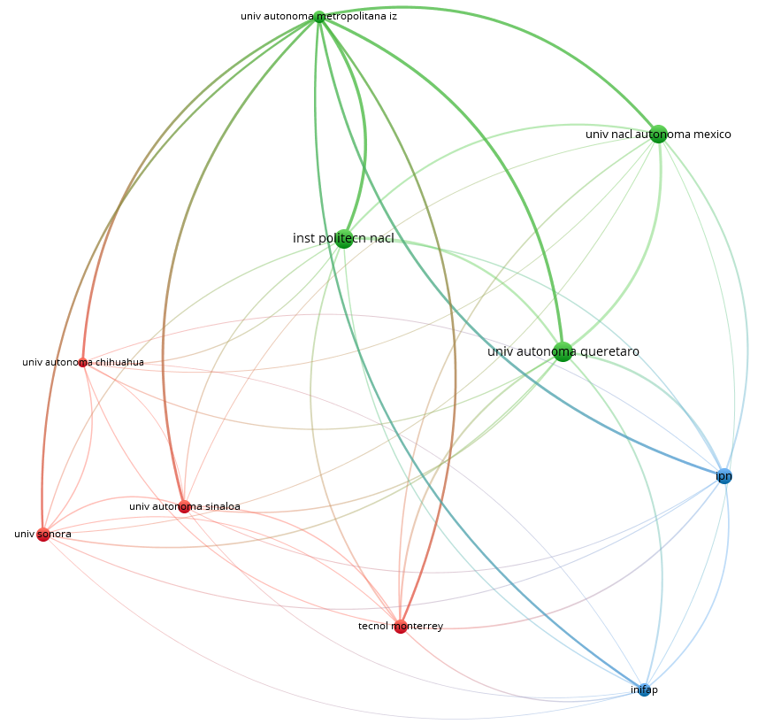

### **Figure 6.** Citation-organization cooperation network on corn nixtamalization from WOS database. (Out of 379 organization searched, 9 organization that published at least nine documents were considered.)

The results of visualization of research mapping related to corn nixtamalization shows 9 items with a total of 379 organizations with at least nine documents published which are divided into 3 clusters in WOS, namely:

1. Cluster 1 consists of 4 items including Tecnológico de Monterrey, Universidad Autónoma de Chihuahua, Universidad Autónoma de Sinaloa, Universidad de Sonora
2. Cluster 2 consists of 4 items including Instituto Politécnico Nacional, Universidad Autónoma Metropolitana-iztapalapa, Universidad Autónoma de Querétaro, Universidad Nacional Autónoma de México
3. Cluster 3 consists of 2 items including INIFAP, IPN

## **Authors and citation relationship**

The construction of mapping of networks through VOSviewer provides visual relationship to study the activity of an author and their interconnectivity with another researcher. Out of 1157 authors obtained in Scopus database, 23 meet the criteria of publishing at least 8 research paper regarding corn nixtamalization shown in Table 5.

### **Table 5.** Most productive authors that published more than 8 documents in Scopus

|  |  |  |  |  |  |
| --- | --- | --- | --- | --- | --- |
| **#** | **Author** | **Documents** | **Citations** | **Average citations per document** | **Total link strength** |
| 1 | Ramírez-Wong, B. | 21 | 174 | 8.29 | 185 |
| 2 | Serna-Saldivar, S.O. | 21 | 366 | 17.43 | 120 |
| 3 | Santiago-Ramos, D. | 16 | 247 | 15.44 | 198 |
| 4 | Gaytán-Martínez, M. | 15 | 221 | 14.73 | 79 |
| 5 | Torres-Chávez, P.I. | 15 | 154 | 10.27 | 155 |
| 6 | Quintero-Ramos, A. | 13 | 140 | 10.77 | 118 |
| 7 | Susilowati, A. | 13 | 17 | 1.31 | 10 |
| 8 | Figueroa-Cárdenas, J.D.D. | 12 | 186 | 15.50 | 152 |
| 9 | Maryati, Y. | 12 | 17 | 1.42 | 10 |
| 10 | Alvarez-Ramirez, J. | 11 | 132 | 12.00 | 41 |
| 11 | Gutiérrez-Uribe, J.A. | 11 | 295 | 26.82 | 82 |
| 12 | Vernon-Carter, E.J. | 11 | 132 | 12.00 | 41 |
| 13 | Escalante-Aburto, A. | 10 | 137 | 13.70 | 170 |
| 14 | Gutiérrez-Cortez, E. | 10 | 193 | 19.30 | 68 |
| 15 | Martínez-Bustos, F. | 10 | 83 | 8.30 | 55 |
| 16 | Rodríguez-García, M.E. | 10 | 260 | 26.00 | 68 |
| 17 | Milán-Carrillo, J. | 9 | 245 | 27.22 | 116 |
| 18 | Morales-Sánchez, E. | 9 | 117 | 13.00 | 25 |
| 19 | Reyes-Moreno, C. | 9 | 246 | 27.33 | 119 |
| 20 | Arámbula-Villa, G. | 8 | 81 | 10.13 | 11 |
| 21 | Gutiérrez-Dorado, R. | 8 | 59 | 7.38 | 52 |
| 22 | Palacios-Rojas, N. | 8 | 92 | 11.50 | 30 |
| 23 | Pérez-Carrillo, E. | 8 | 45 | 5.63 | 37 |

Ramírez-Wong, B. and Serna-Saldivar, S.O. both published 21 research articles followed by Santiago-Ramos, D. (16), Gaytán-Martínez, M. (15) and Torres-Chávez, P.I. (15) who are also the prominent groups in the field of research. However, Reyes-Moreno, C. received the highest average citation per document that is 27.33 followed by Milán-Carrillo, J. (27.22), Gutiérrez-Uribe, J.A. (26.82) and Rodríguez-García, M.E. (26.00). All 21 authors show strong collaboration based on their TLS specifically Santiago-Ramos, D. (198), Ramírez-Wong, B. (185), Escalante-Aburto, A. (170) and Torres-Chávez, P.I. (155).

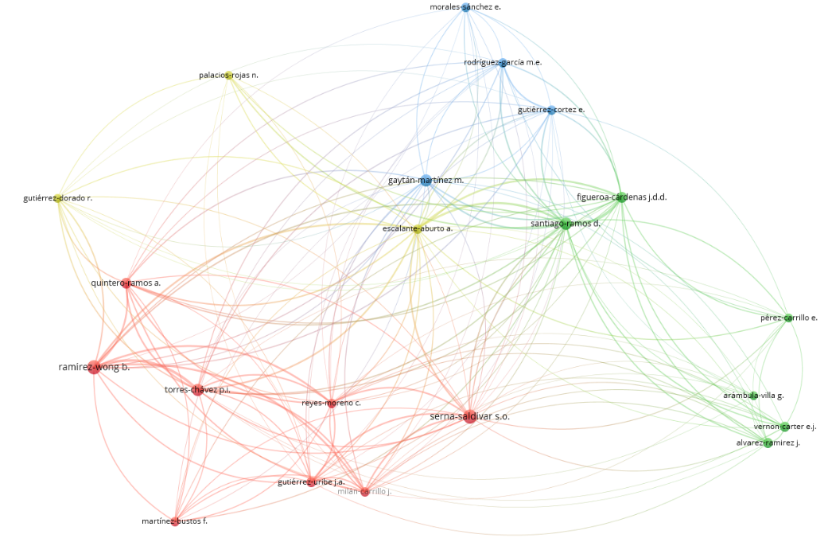

### **Figure 7.** Citation-author cooperation network on corn nixtamalization from Scopus database. (Out of 1157 authors searched, 23 authors that published at least eight documents were considered.)

The results of visualization of research mapping related to corn nixtamalization shows 23 items with a total of 1157 authors with at least eight documents published which are divided into 5 clusters in Scopus, namely:

1. Cluster 1 consists of 8 items including Gutiérrez-Uribe; J.A, Martínez-Bustos, F.; Milán-Carrillo, J.; Quintero-Ramos, A.; Ramírez-Wong, B.; Reyes-Moreno, C.; Serna-Saldivar, S.O.; Torres-Chávez, P.I.,
2. Cluster 2 consists of 6 items including Alvarez-Ramirez, J.; Arámbula-Villa, G.; Figueroa-Cárdenas, J.D.D.; Pérez-Carrillo, E.; Santiago-Ramos, D.; Vernon-Carter, E.J.
3. Cluster 3 consists of 4 items including Gaytán-Martínez, M.; Gutiérrez-Dorado, R.; Morales-Sánchez, E.; Rodríguez-García, M.E.
4. Cluster 4 consists of 3 items including Escalante-Aburto, A.; Gutiérrez-Dorado, R.; Palacios-Rojas, N.
5. Cluster 5 consists of 2 items including Maryati, Y., Susilowati, A.

The largest set of connected items or strong collaborative researchers consists of 21 authors included in Cluster 1 to 4 (Figure 7) and not connected items consists of 2 authors included in Cluster 5 (Figure 8). It was also supported by the TLS of 10 for both Maryati, Y. and Susilowati, A. shown in Table 5. Interestingly, although Maryati, Y. (12) and Susilowati, A. (13) were closed due to the number of their published journals but did not have any collaboration with each other and with any other research group.



### **Figure 8.** Citation-author cooperation network on corn nixtamalization from Scopus database. (23 authors that published at least eight documents, 2 authors with no research collaboration forms a separate cluster)

Nineteen collaborative researchers out of 1324 items were obtained in Web of Science and the most productive author is Santiago-Ramos, David with 22 published articles followed by de Dios Figueroa-Cardenas, Juan (20), Gaytan-Martinez, Marcela (17) and Ramirez-Wong, Benjamin (15) shown in Table 6 and being the prominent groups in corn studies in Figure 8.

### **Table 6.** Most productive authors that published more than 8 documents in WOS

|  |  |  |  |  |  |
| --- | --- | --- | --- | --- | --- |
| **#** | **Author** | **Documents** | **Citations** | **Average Citations** | **Total Link Strength** |
| 1 | Santiago-Ramos, David | 22 | 300 | 13.64 | 351 |
| 2 | de Dios Figueroa-Cardenas, Juan | 20 | 329 | 16.45 | 323 |
| 3 | Gaytan-Martinez, Marcela | 17 | 249 | 14.65 | 205 |
| 4 | Ramirez-Wong, Benjamin | 15 | 105 | 7.00 | 132 |
| 5 | Serna-Saldivar, Sergio O. | 12 | 271 | 22.58 | 192 |
| 6 | Juan Veles-Medina, Jose | 11 | 187 | 17.00 | 247 |
| 7 | Milan-Carrillo, Jorge | 11 | 269 | 24.45 | 165 |
| 8 | Gutierrez-Cortez, E. | 10 | 197 | 19.70 | 95 |
| 9 | Reyes-Moreno, Cuauhtemoc | 10 | 269 | 26.90 | 165 |
| 10 | Alvarez-Ramirez, J. | 9 | 134 | 14.89 | 82 |
| 11 | Escalante-Aburto, Anayansi | 9 | 96 | 10.67 | 197 |
| 12 | Martinez-Bustos, Fernando | 9 | 59 | 6.56 | 67 |
| 13 | Mora-Rochin, Saraid | 9 | 258 | 28.67 | 157 |
| 14 | Palacios-Rojas, Natalia | 9 | 133 | 14.78 | 55 |
| 15 | Rodriguez-Garcia, M. E. | 9 | 239 | 26.56 | 103 |
| 16 | Vernon-Carter, E. J. | 9 | 134 | 14.89 | 82 |
| 17 | Gutierrez-Dorado, Roberto | 8 | 69 | 8.63 | 78 |
| 18 | Perez-Carrillo, Esther | 8 | 75 | 9.38 | 54 |
| 19 | Valderrama-Bravo, C. | 8 | 105 | 13.13 | 70 |

Although de Dios Figueroa-Cardenas, Juan with the highest number of citations of 329 followed by Santiago-Ramos, David (300), Milan-Carrillo, Jorge (269) and Reyes-Moreno, Cuauhtemoc (269), the highest average citations go to Mora-Rochin, Saraid with 28.67 followed by Reyes-Moreno, Cuauhtemoc (26.90), Rodriguez-Garcia, M. E. (26.56) and Milan-Carrillo, Jorge (24.45). TLS of all these 19 authors ranging from 55 to 351 indicates that they have strong collaboration with each other (Figure 9).

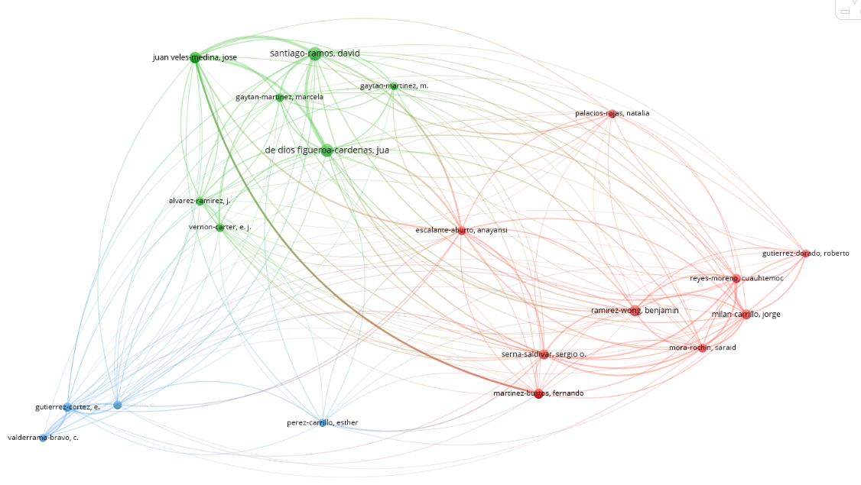

### **Figure 9.** Citation-author cooperation network on corn nixtamalization from WOS database. (Out of 1324 authors searched, 19 authors that published at least eight documents were considered.)

The results of visualization of research mapping related to corn nixtamalization shows 19 items with a total of 1324 authors with at least eight documents published which are divided into 3 clusters in WOS, namely:

1. Cluster 1 consists of 9 items including Escalante-Aburto, Anayansi; Gutierrez-Dorado, Roberto; Martinez-Bustos, Fernando; Milan-Carrillo, Jorge; Mora-Rochin, Saraid; Palacios-Rojas, Natalia; Ramirez-Wong, Benjamin; Reyes-Moreno, Cuauhtemoc; Serna-Saldivar, Sergio O.
2. Cluster 2 consists of 6 items including Alvarez-Ramirez, J.; de Dios Figueroa-Cardenas, Juan; Gaytan-Martinez, Marcela; Juan Veles-Medina, Jose; Santiago-Ramos, David; Vernon-Carter, E. J.
3. Cluster 3 consists of 4 items including Gutierrez-Cortez, E.; Perez-Carrillo, Esther; Rodriguez-Garcia, M. E.; Valderrama-Bravo, C.

## **Documents and citation relationship**

The citation-document network mapping analysis provides information on the quality of the published journal based on higher citation which suggests that the paper had been cited by many researchers. In this review, documents with at least 40 times cited were selected as shown in Table 7 where the top cited document was Nuss & Tanumihardjo, 2010 who reported a review paper about maize as the paramount staple crop in the context of global nutrition followed by the study Flores-Morales et al., 2012 regarding the determination of the structural changes by FT-IR, Raman, and CP/MAS 13C NMR spectroscopy on retrograded starch of maize tortillas then also a review paper by Neme & Mohammed, 2017 about the occurrence of mycotoxins in grains and the role of postharvest management as a mitigation strategies. None of these three top cited journals had been cited by selected group of 17 documents from Scopus.

### **Table 7.** Top documents that have been cited for at least 40 times in Scopus

|  |  |  |  |
| --- | --- | --- | --- |
| **#** | **Documents** | **Citations** | **Links** |
| 1 | Nuss & Tanumihardjo, 2010 | 338 | 1 |
| 2 | Flores-Morales et al., 2012 | 248 | 0 |
| 3 | Neme & Mohammed, 2017 | 170 | 0 |
| 4 | Gwirtz & Nieves Garcia-Casal, 2014 | 143 | 1 |
| 5 | Mora-Rochin et al., 2010 | 143 | 2 |
| 6 | Grenier et al., 2012 | 87 | 1 |
| 7 | Wang et al., 2015 | 77 | 1 |
| 8 | Suri & Tanumihardjo, 2016 | 71 | 4 |
| 9 | Lopez-Martinez et al., 2011 | 67 | 1 |
| 10 | Rodriguez-Miranda et al., 2011 | 66 | 0 |
| 11 | Torres et al., 2015 | 52 | 0 |
| 12 | Santiago-Ramos, de Dios Figueroa-Cardenas, et al., 2018 | 44 | 1 |
| 13 | Grenier et al., 2014 | 43 | 0 |
| 14 | Cornejo-Villegas et al., 2010 | 43 | 0 |
| 15 | Chávez-Santoscoy et al., 2016 | 42 | 1 |
| 16 | Palacios-Fonseca et al., 2013 | 41 | 0 |
| 17 | Gutierrez-Cortez et al., 2010 | 41 | 1 |

Suri & Tanumihardjo, 2016 with the study about the effects of different processing methods on the micronutrient and phytochemical contents of maize from A to Z had been cited the most with four times seen in Figure 10 supported by cluster 1 while Mora-Rochin et al., 2010 had been cited twice supported by cluster 3. It can also be observed in Figure 10 that there are two distinct highly interconnected clusters (red and blue nodes) wherein the first group, the document from Nuss & Tanumihardjo, 2010 was the most cited publication with 338 citations followed by Gwirtz & Nieves Garcia-Casal, 2014 (143) and in the second group it was Mora-Rochin et al., 2010 (143). Flores-Morales et al., 2012 and Neme & Mohammed, 2017 citations of 248 and 170, respectively are not interconnected with other publications. Gwirtz & Nieves Garcia-Casal, 2014 study is about processing of maize flour and corn meal food products while Mora-Rochin et al., 2010 was phenolic content and antioxidant activity of tortillas produced from pigmented maize processed by conventional nixtamalization or extrusion cooking. Chávez-Santoscoy et al., 2016 had the same cluster with Mora-Rochin et al., 2010 where the cited document is production of maize tortillas and cookies from nixtamalized flour enriched with anthocyanins, flavonoids and saponins extracted from black bean (Phaseolus vulgaris) seed coats.

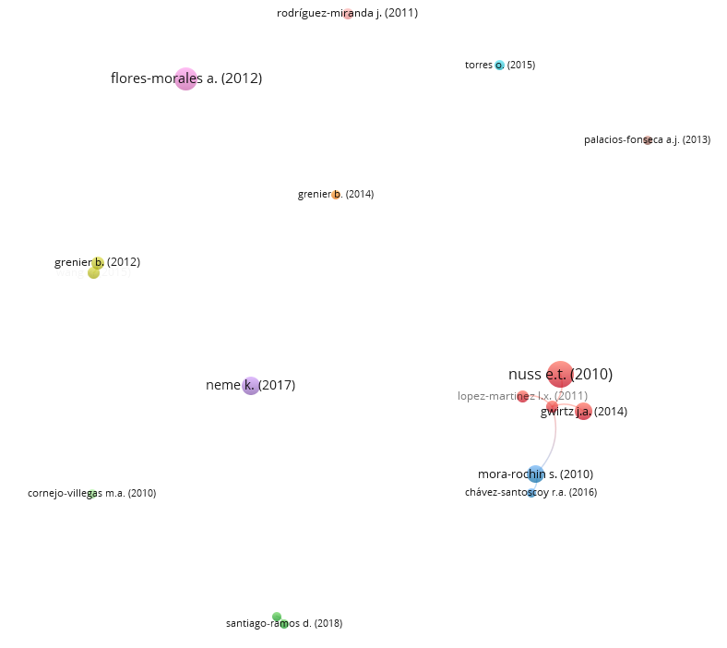

### **Figure 10.** Citation-document cooperation network on corn nixtamalization from Scopus database. (Out of 364 documents searched, 17 documents have been cited for at least 40 times were considered.)

The results of visualization of research mapping related to corn nixtamalization shows 17 items with a total of 364 documents with at least forty times had been cited which are divided into 11 clusters in Scopus, namely:

1. Cluster 1 consists of 4 items including Gwirtz & Nieves Garcia-Casal, 2014, Lopez-Martinez et al., 2011, Nuss & Tanumihardjo, 2010, Suri & Tanumihardjo, 2016
2. Cluster 2 consists of 2 items including Gutierrez-Cortez et al., 2010, Santiago-Ramos, de Dios Figueroa-Cardenas, et al., 2018
3. Cluster 3 consists of 2 items including Chávez-Santoscoy et al., 2016, Mora-Rochin et al., 2010
4. Cluster 4 consists of 2 items including Grenier et al., 2014, Wang et al., 2015
5. Cluster 5 consists of 1 item including Neme & Mohammed, 2017
6. Cluster 6 consists of 1 item including Torres et al., 2015
7. Cluster 7 consists of 1 item including Grenier et al., 2012
8. Cluster 8 consists of 1 item including Palacios-Fonseca et al., 2013
9. Cluster 9 consists of 1 item including Flores-Morales et al., 2012
10. Cluster 10 consists of 1 item including Rodriguez-Miranda et al., 2011
11. Cluster 11 consists of 1 item including Cornejo-Villegas et al., 2010

364 documents have found in Scopus while 370 documents in Web of Science. Table 8 shows the data from WOS wherein the top cited documents were Nuss & Tanumihardjo, 2010 with 306 citations followed by Flores-Morales et al., 2012 (234) and Neme & Mohammed 2017 (149). It was the same with Scopus shown in Table 7 while with the slight difference in the citations of Mora-Rochin et al., 2010 and Gwirtz & Nieves Garcia-Casal, 2014.

### **Table 8.** Top documents that have been cited for at least 40 times in WOS

|  |  |  |  |
| --- | --- | --- | --- |
| **#** | **Document** | **Citations** | **Links** |
| 1 | Nuss & Tanumihardjo, 2010 | 306 | 1 |
| 2 | Flores-Morales et al., 2012 | 234 | 0 |
| 3 | Neme & Mohammed 2017 | 149 | 1 |
| 4 | Mora-Rochin et al., 2010 | 134 | 3 |
| 5 | Gwirtz & Nieves Garcia-Casal, 2014 | 129 | 1 |
| 6 | Grenier et al., 2012 | 86 | 1 |
| 7 | Suarez Meraz et al., 2016 | 82 | 0 |
| 8 | Milani & Maleki, 2014 | 80 | 1 |
| 9 | Wang et al., 2016 | 75 | 1 |
| 10 | Suri & Tanumihardjo, 2016 | 61 | 4 |
| 11 | Castro-Munoz & Yanez-Fernandez, 2015 | 58 | 0 |
| 12 | Lopez-Martinez et al., 2011 | 56 | 2 |
| 13 | Torres et al., 2015 | 53 | 0 |
| 14 | Aguayo-Rojas et al., 2012 | 49 | 3 |
| 15 | Fernandez Suarez et al., 2013 | 46 | 2 |
| 16 | Rodriguez-Miranda et al., 2011 | 46 | 0 |
| 17 | Grenier et al., 2014 | 41 | 0 |
| 18 | Pérez-Flores et al., 2011 | 40 | 0 |

Suri & Tanumihardjo, 2016 also had been the most cited with four times followed by Mora-Rochin et al., 2010 and Aguayo-Rojas et al., 2012 cited three times while Lopez-Martinez et al., 2011 and Fernandez Suarez et al., 2013 cited twice with other selected group of 7 documents from WOS shown in Figure 11. The study of Aguayo-Rojas et al., 2012 is about phytochemicals and antioxidant capacity of tortillas obtained after lime-cooking extrusion process of whole pigmented Mexican maize while Lopez-Martinez et al., 2011 was phase II-inducing, polyphenols content and antioxidant capacity of corn (Zea mays L.) from phenotypes of white, blue, red and purple colors processed into masa and tortillas and Fernandez Suarez et al., 2013 was a review paper about the importance of Mexican maize landraces in the national diet. Figure 11 also shows two major interconnected clusters (green and red nodes) where the first group includes Nuss & Tanumihardjo, 2010 and Gwirtz & Nieves Garcia-Casal, 2014 while in the second group consist of Mora-Rochin et al., 2010. This can be concluded that the publications of Nuss & Tanumihardjo, 2010, Gwirtz & Nieves Garcia-Casal, 2014 and Mora-Rochin et al., 2010 had significant impact on the research involving corn nixtamalization between 2010 to 2023 in both Scopus and WOS databases. Documents of Chávez-Santoscoy et al., 2016 in blue nodes from Scopus (Figure 10) and Aguayo-Rojas et al., 2012, Lopez-Martinez et al., 2011, Fernandez Suarez et al., 2013 shown in red nodes for WOS (Figure 11) had close distance with Mora-Rochin et al., 2010 because their studies had the same interest which focus on phytochemicals from pigmented maize and other crops.

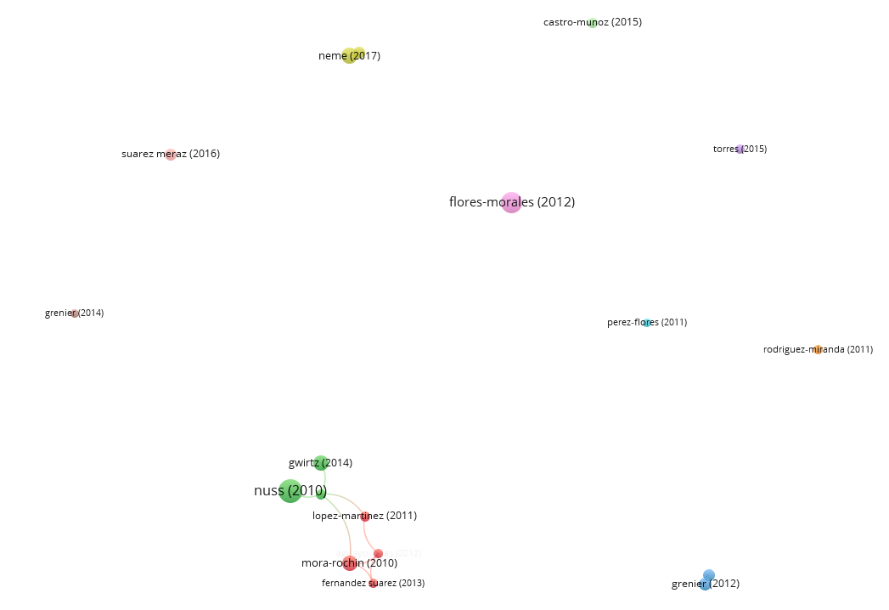

### **Figure 11.** Citation-document cooperation network on corn nixtamalization from WOS database. (Out of 370 documents searched, 18 documents have been cited for at least 40 times were considered.)

The results of visualization of research mapping related to corn nixtamalization shows 18 items with a total of 370 documents with at least forty times had been cited which are divided into 11 clusters in Scopus, namely:

1. Cluster 1 consists of 4 items including Aguayo-Rojas et al., 2012, Fernandez Suarez et al., 2013, Lopez-Martinez et al., 2011, Mora-Rochin et al., 2010
2. Cluster 2 consists of 3 items including Gwirtz & Nieves Garcia-Casal, 2014, Nuss & Tanumihardjo, 2010, Suri & Tanumihardjo, 2016
3. Cluster 3 consists of 2 items including Grenier et al., 2012, Wang et al., 2016
4. Cluster 4 consists of 2 items including Milani & Maleki, 2014, Neme & Mohammed 2017
5. Cluster 5 consists of 1 item including Torres et al., 2015
6. Cluster 6 consists of 1 item including Pérez-Flores et al., 2011
7. Cluster 7 consists of 1 item including Rodriguez-Miranda et al., 2011
8. Cluster 8 consists of 1 item including Grenier et al., 2014
9. Cluster 9 consists of 1 item including Flores-Morales et al., 2012
10. Cluster 10 consists of 1 item including Suarez Meraz et al., 2016
11. Cluster 11 consists of 1 item including Castro-Munoz & Yanez-Fernandez, 2015

## **Most productive journals in corn nixtamalization**

The citation-sources relationship obtained from bibliometric mapping analysis by VOSviewer indicates the importance of where the author prefers to publish their results related to corn nixtamalization. These can be seen in Table 5 it was Journal of Cereal Science with 26 articles followed by Cereal Chemistry (17), CyTA - Journal of Food (16) and Food Chemistry (13) which received citations of 482, 123, 207 and 203, respectively.

### **Table 9.** Top journal sources where more than five documents were published from Scopus

|  |  |  |  |  |  |  |
| --- | --- | --- | --- | --- | --- | --- |
| **#** | **Source** | **Documents** | **Citations** | **Average citations per document** | **Impact factor (2021) b** | **Total link strength** |
| 1 | Journal of Cereal Science | 26 | 482 | 18.54 | 4.075 | 87 |
| 2 | Cereal Chemistry | 17 | 123 | 7.24 | 2.534 | 35 |
| 3 | CyTA - Journal of Food | 16 | 207 | 12.94 | 2.478 | 27 |
| 4 | Food Chemistry | 13 | 203 | 15.62 | 9.231 | 34 |
| 5 | LWT - Food Science and Technology | 12 | 253 | 21.08 | 6.056 | 22 |
| 6 | Plant Foods for Human Nutrition | 12 | 227 | 18.92 | 4.124 | 36 |
| 7 | Revista Mexicana de Ingeniera Quimica | 10 | 107 | 10.70 | 2.093 | 8 |
| 8 | Revista Fitotecnia Mexicana | 9 | 67 | 7.44 | 0.418 | 4 |
| 9 | International Journal of Gastronomy and Food Science | 8 | 21 | 2.63 | 3.350 | 17 |
| 10 | Journal of Food Science | 8 | 105 | 13.13 | 3.693 | 19 |
| 11 | Journal of Food Engineering | 7 | 207 | 29.57 | 6.203 | 33 |
| 12 | Journal of Food Processing and Preservation | 7 | 27 | 3.86 | 2.609 | 16 |
| 13 | Journal of Food Process Engineering | 6 | 82 | 13.67 | 2.889 | 22 |
| 14 | Journal of Food Science and Technology | 6 | 56 | 9.33 | 3.117 | 10 |
| 15 | AIP Conference Proceedings | 5 | 3 | 0.60 | 0.400 | 0 |
| 16 | Food Control | 5 | 211 | 42.20 | 6.652 | 2 |
| 17 | IOP Conference Series: Materials Science and Engineering | 5 | 1 | 0.20 | 0.480 | 0 |
| 18 | Journal of Archaeological Science | 5 | 61 | 12.20 | 3.508 | 2 |
| 19 | Starch/Staerke | 5 | 19 | 3.80 | 2.688 | 6 |

In terms of average citations per document, the top four journal sources were Food Control (42.20), Journal of Food Engineering (29.57), LWT - Food Science and Technology (21.08) and Plant Foods for Human Nutrition (18.92) with impact factor (2021) of 6.652, 6.203, 6.056 and 4.124, respectively which indicates the impactful articles being published had high-quality research work.

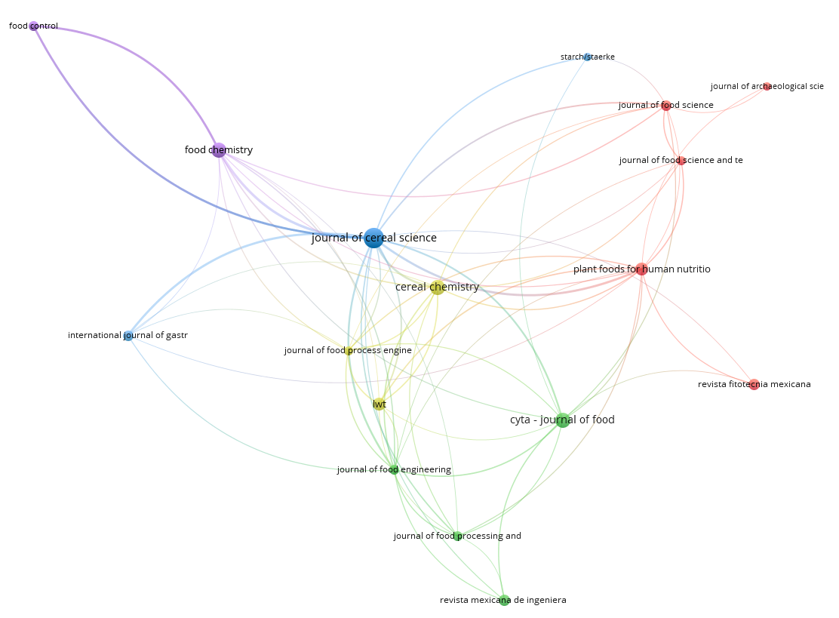

### **Figure 12.** Citation-sources cooperation network on corn nixtamalization from Scopus database. (Out of 146 sources searched, 19 documents have been cited for at least five documents were considered.)

The results of visualization of research mapping related to corn nixtamalization shows 19 items with a total of 146 sources with at least 5 documents published which are divided into 7 clusters in Scopus, namely:

1. Cluster 1 consists of 5 items including Journal of Archaeological Science, Journal of Food Science, Journal of Food Science and Technology, Plant Foods for Human Nutrition, Revista Fitotecnia Mexicana
2. Cluster 2 consists of 4 items including CyTA - Journal of Food, Journal of Food Engineering, Journal of Food Processing and Preservation, Revista Mexicana de Ingeniera Quimica
3. Cluster 3 consists of 3 items including International Journal of Gastronomy and Food Science, Journal of Cereal Science, Starch/Staerke
4. Cluster 4 consists of 3 items including Cereal Chemistry, Journal of Food Process Engineering, LWT - Food Science and Technology
5. Cluster 5 consists of 2 items including Food Chemistry, Food Control
6. Cluster 6 consists of 1 item including AIP Conference Proceedings
7. Cluster 7 consists of 1 item including IOP Conference Series: Materials Science and Engineering

The largest set of connected items consists of 17 journal sources included in cluster 1 to 5 (Figure 12) and 2 sources not being collaborative included in cluster 6 and 7 (Figure 13). This was supported with data shown in Table 9 that AIP Conference Proceedings and IOP Conference Series: Materials Science and Engineering had 0 or no TLS.

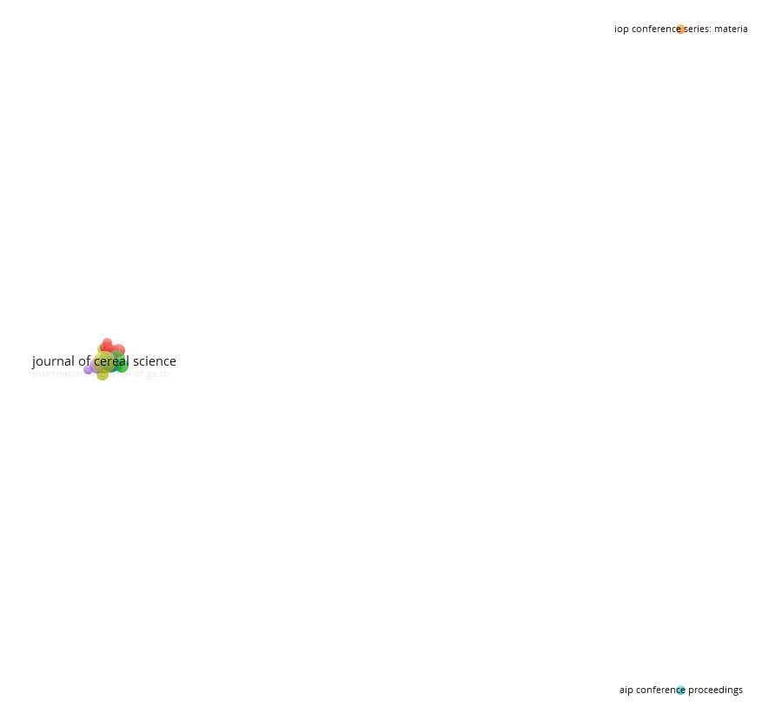

### **Figure 13.** Citation-sources cooperation network on corn nixtamalization from Scopus database. (19 sources with at least five documents, 2 sources with no research collaboration forms each separate cluster)

The top 3 journal sources in Web of Science are the same with the bibliometric mapping analysis from VOSviewer obtained in Scopus namely Journal of Cereal Science, Cereal Chemistry and CyTA - Journal of Food with published journals of 30, 18 and 17, respectively while the most cited sources is Journal of Cereal Science with 483 citations followed by Plant Foods for Human Nutrition (265), LWT - Food Science and Technology (238) and Food Chemistry (201).

### **Table 10.** Top journal sources where more than five documents were published from WOS

|  |  |  |  |  |  |  |
| --- | --- | --- | --- | --- | --- | --- |
| **#** | **Sources** | **Documents** | **Citations** | **Average citations per document** | **Impact factor (2021)b** | **Total link strength** |
| 1 | Journal of Cereal Science | 30 | 483 | 16.10 | 4.075 | 196 |
| 2 | Cereal Chemistry | 18 | 142 | 7.89 | 2.534 | 74 |
| 3 | CyTA - Journal of Food | 17 | 193 | 11.35 | 2.478 | 60 |
| 4 | LWT - Food Science and Technology | 14 | 238 | 17.00 | 6.056 | 78 |
| 5 | Plant Foods for Human Nutrition | 14 | 265 | 18.93 | 4.124 | 70 |
| 6 | Food Chemistry | 13 | 201 | 15.46 | 9.231 | 83 |
| 7 | Journal of Food Science | 12 | 131 | 10.92 | 3.693 | 57 |
| 8 | Revista Fitotecnia Mexicana | 12 | 114 | 9.50 | 0.418 | 17 |
| 9 | Revista Mexicana de Ingenieria Quimica | 12 | 108 | 9.00 | 2.093 | 40 |
| 10 | Journal of Food Engineering | 9 | 197 | 21.89 | 6.203 | 83 |
| 11 | Journal of Food Processing and Preservation | 9 | 27 | 3.00 | 2.609 | 43 |
| 12 | International Journal of Food Science and Technology | 8 | 87 | 10.88 | 3.612 | 45 |
| 13 | Starch-Starke | 8 | 27 | 3.38 | 2.688 | 17 |
| 14 | International Journal of Gastronomy and Food science | 6 | 12 | 2.00 | 3.350 | 28 |
| 15 | Journal of Food Process Engineering | 6 | 77 | 12.83 | 2.889 | 48 |
| 16 | Journal of Food Science and Technology - Mysore | 6 | 47 | 7.83 | 3.117 | 25 |
| 17 | Food Control | 5 | 180 | 36.00 | 6.652 | 6 |
| 18 | Molecules | 5 | 42 | 8.40 | 4.927 | 28 |

The top journal sources with highest citations per documents were Food Control with 36 citations followed by Journal of Food Engineering (21.89), Plant Foods for Human Nutrition (18.93) and LWT - Food Science and Technology (17.00) with impact factor (2021) of 6.652, 6.203, 4.124 and 6.056. There is only a difference in number of journals published and citations between Plant Foods for Human Nutrition and LWT - Food Science and Technology in Scopus and Web of Science database. The TLS ranging from 6 to 196 indicates that these sources were been collaborative with each other shown in Figure 14.

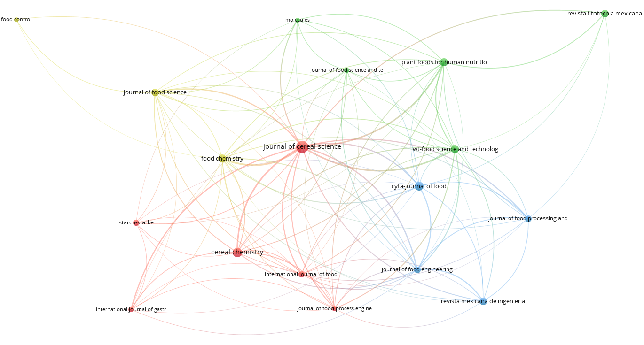

### **Figure 14.** Citation-sources cooperation network on corn nixtamalization from WOS database. (Out of 134 sources searched, 18 documents have been cited for at least five documents were considered.)

The results of visualization of research mapping related to corn nixtamalization shows 18 items with a total of 134 sources with at least 5 documents published which are divided into 4 clusters in WOS, namely:

1. Cluster 1 consists of 6 items including Cereal Chemistry, International Journal of Food Science and Technology, International Journal of Gastronomy and Food science, Journal of Cereal Science, Journal of Food Process Engineering, Starch-Starke
2. Cluster 2 consists of 5 items including Journal of Food Science, LWT - Food Science and Technology, Molecules, Plant Foods for Human Nutrition, Revista Fitotecnia Mexicana
3. Cluster 3 consists of 4 items including CyTA - Journal of Food, Journal of Food Engineering, Journal of Food Processing and Preservation, Revista Mexicana de Ingenieria Quimica
4. Cluster 4 consists of 3 items including Food Chemistry, Food Control, Journal of Food Science

## **Network visualization of corn nixtamalization based on keywords**

Identifying co-occurrence-all keywords relationship between terms in the topic of corn nixtamalization are selected for network visualization map shown in Figure 15 and 16. Determining the top ten highest occurrences of keywords in Scopus are nixtamalization (142), zea mays (116), maize (101), article (44), chemistry (42), starch (40), food handling (34), flour (31), tortillas (30) and calcium (28) with strong TLS with each word. Red, violet, and blue nodes where contained the most occurrences keywords are nixtamalization, zea mays and maize, respectively suggesting strong correlation with other nodes. Violet nodes also includes food handling, in blue nodes are article and tortillas, in yellow it is chemistry while in green nodes includes starch, flour and calcium.

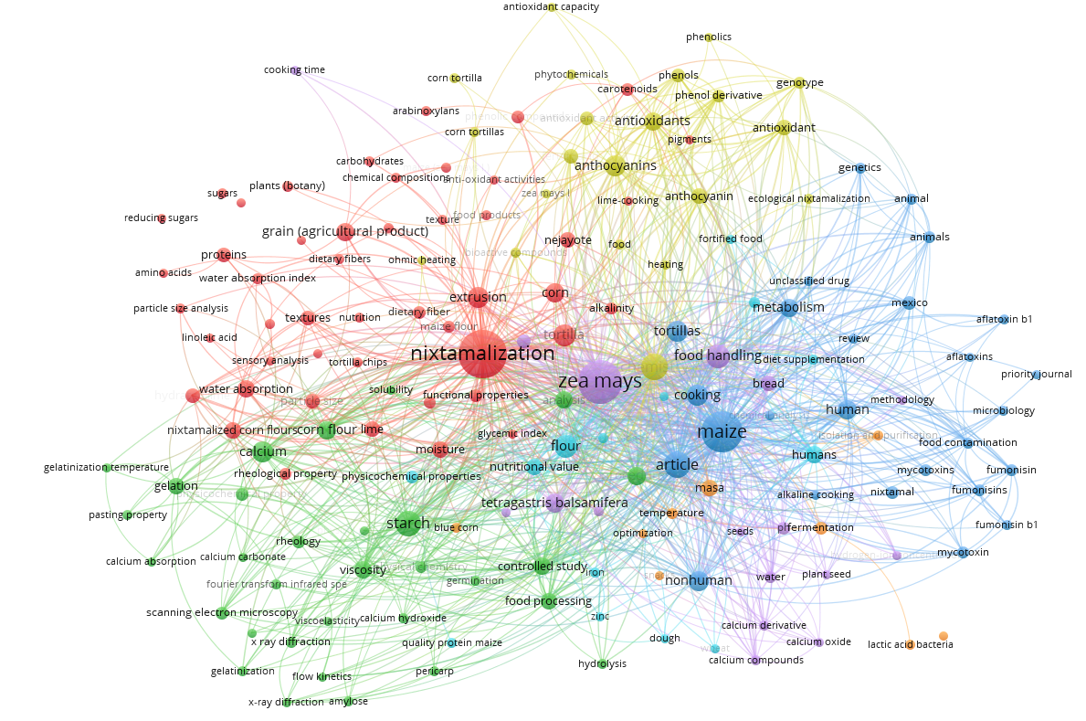

### **Figure 15.** Co-occurrence-keywords cooperation network visualization with five as the minimum number of occurrences of a keyword in Scopus

The results of visualization of research mapping related to corn nixtamalization shows 166 items with a total of 2423 linked keywords which are divided into 7 clusters in Scopus, namely:

1. Cluster 1 consists of 48 items including alkalinity, amino acids, anti-oxidant activities, arabinoxylans, carbohydrates, carotenoids, chemical compositions, corn, dietary fiber, dietary fibers, effluents, extrusion, extrusion process, food products, functional properties, glycemic index, grain (agricultural product), hydrated lime, lime, lime-cooking, linoleic acid, maize (zea mays l.), maize flour, mixtures, moisture, nejayote, nixtamalization, nixtamalized corn flours, nutrition, particle size, particle size analysis, phenolic compounds, pigments, plants (botany), proteins, reducing sugars, resistant starch, rheological property, sensory analysis, sugars, textural properties, texture, textures, tortilla, tortilla chips, water absorption, water absorption capacity, water absorption index.
2. Cluster 2 consists of 31 items including amylose, amylose-lipid complex, analysis, calcium, calcium absorption, calcium carbonate, calcium hydroxide, controlled study, corn flour, flow kinetics, food processing, fourier transform infrared, gelatinization, gelatinization temperature, gelation, germination, hydrolysis, pasting property, pericarp, physical chemistry, physical parameters, physicochemical property, procedures, rheology, scanning electron microcopy, solubility, starch, viscoelasticity, viscosity, x ray diffraction, x-ray diffraction.
3. Cluster 3 consists of 26 items including aflatoxin b1, aflatoxins, alkaline cooking, animal, animals, article, chemical analysis, cooking, food contamination, fumonisin, fumonisin b1, fumonisins, genetics, human, maize, metabolism, mexico, microbiology, mycotoxin, mycotoxins, nixtamal, nonhuman, priority journal, review, tortillas, unclassified drug.
4. Cluster 4 consists of 21 items including anthocyanin, anthocyanins, antioxidant, antioxidant activity, antioxidant capacity, antioxidants, bioactive compounds, chemistry, corn tortilla, corn tortillas, ecological nixtamalization, ferulic acid, food, genotype, heating, ohmic heating, phenol derivative, phenolics, phenols, phytochemical, zea mays l.
5. Cluster 5 consists of 17 items including bread, calcium compounds, calcium derivative, calcium oxide, color, cooking time, food handling, hardness, hydrogen-ion concentration, methodology, nixtamalized maize flour, ph, plant seed, seeds, tetragastris balsamifera, water, zea mays.
6. Cluster 6 consists of 14 items including diet supplementation, dough, flour, food technology, food fortified, fortified food, humans, iron, nutritional value, physicochemical properties, protein quality, quality protein maize, wheat, zinc.
7. Cluster 7 consists of 9 items including blue corn, fermentation, isolation and purification, lactic acid bacteria, masa, optimization, pozol, snacks, temperature.

Compared to Scopus, the top ten highest occurrences of keywords in Web of Science are nixtamalization (157), maize (101), corn (84), masa (77), tortillas (68), starch, tortilla (54), antioxidant activity (53), quality (48), anthocyanins (40) and physicochemical properties (36) with strong TLS. Color of prominent nodes include red, yellow, blue, and green for nixtamalization, masa, maize, and antioxidant activity, respectively. Red nodes also include tortilla, starch, and physicochemical properties, in blue nodes are corn and tortillas while in green is anthocyanins taking into account that in some documents the spelling of most of the keywords such as tortilla may vary from singular to plural.

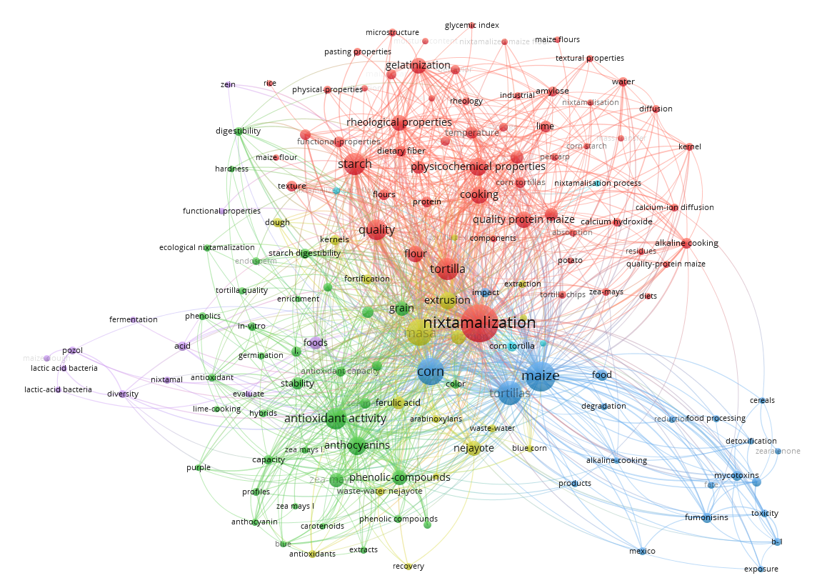

### **Figure 16.** Co-occurrence-keywords cooperation network visualization with five as the minimum number of occurrences of a keyword in WOS

The results of visualization of research mapping related to corn nixtamalization shows 151 items with a total of 1652 linked keywords which are divided into 6 clusters in WOS, namely:

1. Cluster 1 consists of 59 items including absorption, alkaline cooking, amylose, behavior, calcium, calcium hydroxide, calcium-ion diffusion, components, cooking, corn flour, corn starch, corn tortillas, dietary fiber, diets, diffusion, digestion, flour, flours, functional-properties, gelatinization, glycemic index, industrial, kernel, lime, maize flour, maize flours, maize starch, mass-transfer, microstructure, moisture-content, nixtamalisation, nixtamalization, nixtamalized maize flour, pasting properties, pericarp, physical-properties, physicochemical properties, potato, protein, quality, quality protein maize, quality-protein maize, residues, resistant starch, rheological starch, rheological properties, rheology, rice, sorghum, starch, storage, temperature, textural properties, texture, thermal-properties, tortilla, tortilla chips, water, wheat, zea-mays.
2. Cluster 2 consists of 37 items including anthocyanin, anthocyanins, antioxidant, antioxidant activity, antioxidant capacity, blue, capacity, carotenoids, chemical-composition, color, digestibility, ecological nixtamalization, endosperm, enrichment, extracts, germination, grain, hardness, hybrids, in-vitro, l., lime-cooking, phenolic compounds, phenolic-compounds, phenolics, pigmented maize, polyphenols, profiles, purple, stability, starch digestibility, tortilla quality, traditional nixtamalization, zea mays, zea mays l, zea mays l., zea-mays l.
3. Cluster 3 consists of 21 items including aflatoxins, alkaline-cooking, b-1, cereals, corn, degradation, detoxification, exposure, fate, food, food processing, fumonisins, impact, maize, mexico, mycotoxins, products, reduction, tortillas, toxicity, zearalenone.
4. Cluster 4 consists of 18 items including antioxidants, arabinoxylans, bioactive compounds, blue corn, dough, extraction, extrusion, ferulic acid, fortification, kernels, masa, nejayote, optimization, profile, recovery, tortilla texture, waste-water, waste-water nejayote.
5. Cluster 5 consists of 12 items including acid, diversity, evaluate, fermentation, foods, functional properties, lactic acid bacteria, lactic-acid bacteria, maize dough, nixtamal, pozol, zein.
6. Cluster 6 consists of 4 items including corn tortilla, nixtamalisation process, nixtamalized corn flour, tryptophan.

## **Density visualization of corn nixtamalization based on text data**

441 documents obtained in Scopus and WOS when merged. Occurrences of a term extracted from title and abstract fields to obtain results from mapped text data with full counting method. 386 words meet the threshold of 10 occurrences out of 9917 items. With 60% most relevant terms default set by VOSviewer, 232 terms are selected. The density color of term indicates how often that term occurs in yearly published article. Determining the distinct top five highest occurrences of a term in merged database includes maize (413), concentration (185), starch (116), Mexico (103) and kernel (91) with relevance score of 0.3315, 0.1465, 0.6493, 0.3981 and 0.3879, respectively.

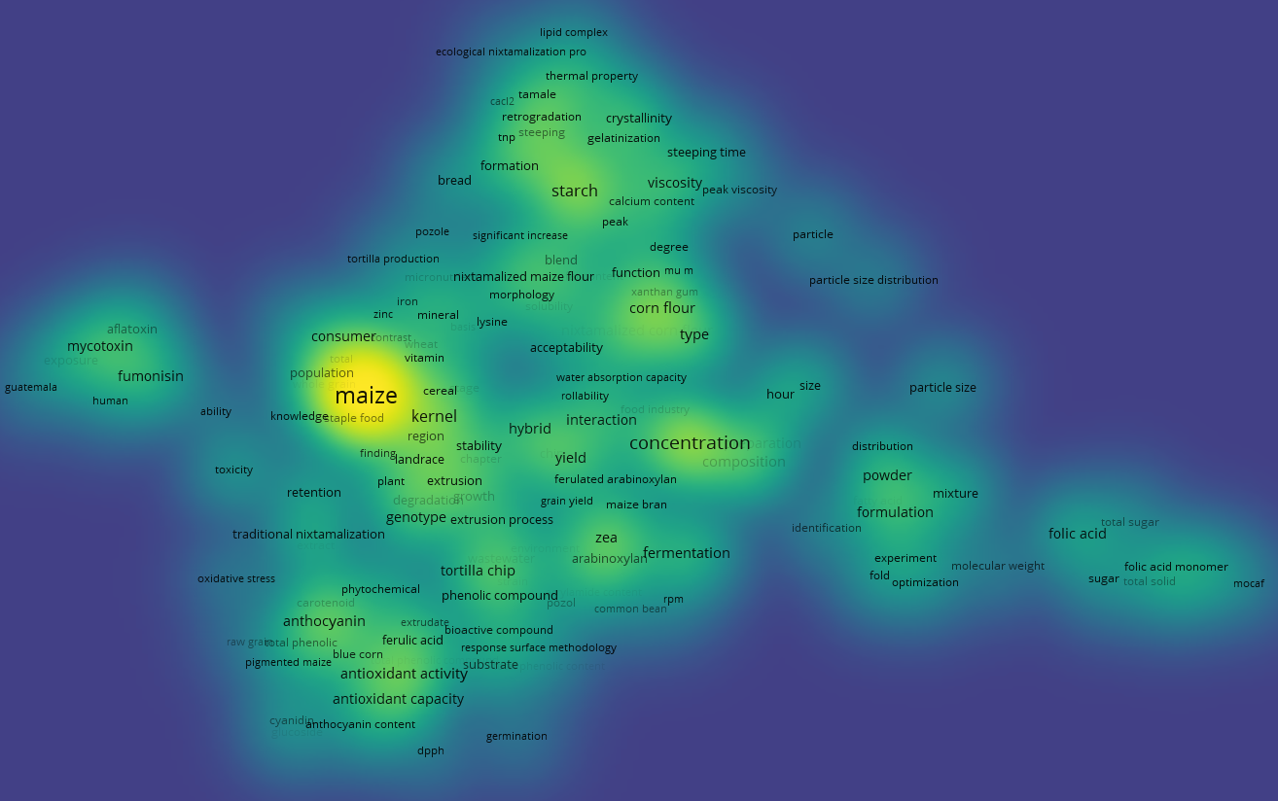

### **Figure 17.** Density visualization with ten as the minimum number of occurrences of a term in merged Scopus and WOS titles and abstracts

The density visualization map was created and shown in Figure 17. The terms were manually screened such that only related to corn nixtamalization are selected. It is quite understandable that one of the relevant terms is starch from merged databases. Nixtamalization modifies the properties of corn produces significant amount of resistant starch. Therefore, it is interesting to identify most relevant studies regarding corn nixtamalization that focuses on starch.

### **Table 11.** List of relevant journals related to starch

|  |  |  |  |  |
| --- | --- | --- | --- | --- |
| **#** | **Authors** | **Title** | **Year** | **Citations** |
| 1 | Dorantes-Campuzano et al. | Effect of maize processing on amylose-lipid complex in pozole, a traditional Mexican dish | 2022 | 3 |
| 2 | Gutiérrez-Cortez et al., | Changes in the physicochemical properties of maize endosperm, endosperm fractions, and isolated starches because of nixtamalization | 2022 | 0 |
| 3 | Martin Enriquez-Castro et al. | Physicochemical, Rheological, and Morphological Characteristics of Products from Traditional and Extrusion Nixtamalization Processes and Their Relation to Starch | 2020 | 11 |
| 4 | Rojas-Molina et al. | Physicochemical Properties and Resistant Starch Content of Corn Tortilla Flours Refrigerated at Different Storage Times | 2020 | 9 |
| 5 | Roldan-Cruz et al. | Microstructural Changes and In Vitro Digestibility of Maize Starch Treated with Different Calcium Compounds Used in Nixtamalization Processes | 2020 | 2 |
| 6 | Musita et al. | Nixtamalization Application as A Quality Improvement of Corn Flour | 2019 | 1 |
| 7 | de los Angeles Cornejo-Villegas et al. | The effect of Ca2+ ions on the pasting, morphological, structural, vibrational, and mechanical properties of corn starch-water system | 2018 | 23 |
| 8 | Preciado-Ortíz et al. | Fatty acids and starch properties of high-oil maize hybrids during nixtamalization and tortilla-making process | 2018 | 13 |
| 9 | Mariscal-Moreno et al. | Nixtamalization Process Affects Resistant Starch Formation and Glycemic Index of Tamales | 2017 | 16 |
| 10 | Santiago-Ramos et al. | Changes in the thermal and structural properties of maize starch during nixtamalization and tortilla-making processes as affected by grain hardness | 2017 | 34 |
| 11 | Santiago-Ramos et al. | Resistant Starch Formation in Tortillas from an Ecological Nixtamalization Process | 2015 | 32 |
| 12 | Lobato-Calleros et al. | Effect of lime concentration on gelatinized maize starch dispersions properties | 2015 | 22 |
| 13 | Mariscal Moreno et al. | The effect of different nixtamalisation processes on some physicochemical properties, nutritional composition and glycemic index | 2015 | 21 |
| 14 | Figueroa et al. | Effect of Traditional Nixtamalization Process on Starch Annealing and the Relation to Pozole Quality | 2013 | 12 |
| 15 | Flores-Morales et al. | Determination of the structural changes by FT-IR, Raman, and CP/MAS 13C NMR spectroscopy on retrograded starch of maize tortillas | 2012 | 248 |

The most cited paper for starch studies is publication from Flores-Morales et al., 2012with 248 citations followed by the two published journals from Santiago-Ramos et al., 2015 & 2017 with 32 and 34 citations. These studies can enhance the food quality especially for the consumption of corn-based food products.

# **Conclusion**

This review paper discusses the bibliometric mapping analysis focuses on citations and co-occurrence. Based on the results and discussion, it can be concluded that VOSviewer is a useful tool in analyzing bibliometric data taken from Scopus and Web of Science. The information from 364 and 370 publications from both databases shows that in the year of 2013 until 2019 resulted to an increase in number of corn nixtamalization related studies and the most published year was in 2020 even though pandemic occurred. Mexico being the most collaborative country followed by United States, Spain and Indonesia since these countries consider corn as their staple food which can be eaten by itself, processed into popular Mexican dish such as tortilla or other products such as sweeteners, corn meals and snacks. Top organizations from Scopus shows no collaboration based on TLS and vice versa in Web of Science which is mostly from Mexico. Most productive authors in Scopus are Ramírez-Wong, Benjamin and Serna-Saldivar, Sergio O. while in Web of Science, they are de Dios Figueroa-Cardenas, Juan and Gaytan-Martinez, Marcela. Santiago-Ramos, David is the third most productive author in Scopus and first in Web of Science. Most cited documents are from publications of Nuss & Tanumihardjo, 2010, Flores-Morales et al., 2012 and Neme & Mohammed, 2017 with either 0 or 1 links found in different clusters while document from Suri & Tanumihardjo, 2016 had the highest link of 4. The most preferred journals sources include Journal of Cereal Science, Cereal Chemistry and CyTA - Journal of Food. Keywords commonly occurs are nixtamalization, corn and maize while one of the relevant occurrences of a term in merged databases is starch. Journals that focus on starch are listed and the most cited document is the published paper from Flores-Morales et al., 2012.

Due to VOSviewer limitations, it is recommended to use other bibliometric software such as Bibliometrix an R package capable of importing data from both databases that uses statistical programming language.

# **Acknowledgements**

# **Credit authorship contribution statement**

**Lady Shernalyn P. Cadavero:** Conceptualization, Writing – original draft.

**Clarissa B. Juanico:** Conceptualization, Supervision**. Aldrin P. Bonto:** Conceptualization, Writing, Supervision

# **References**

Aguayo-Rojas, J., Mora-Rochin, S., Cuevas-Rodriguez, E. O., Serna-Saldivar, S. O., Gutierrez-Uribe, J. A., Reyes-Moreno, C., & Milan-Carrillo, J. (2012). Phytochemicals and Antioxidant Capacity of Tortillas Obtained after Lime-Cooking Extrusion Process of Whole Pigmented Mexican Maize. *PLANT FOODS FOR HUMAN NUTRITION*, *67*(2), 178–185. https://doi.org/10.1007/s11130-012-0288-y

Carrera, Y., Utrilla-Coello, R., Bello-Pérez, A., Alvarez-Ramirez, J., & Vernon-Carter, E. J. (2015). In vitro digestibility, crystallinity, rheological, thermal, particle size and morphological characteristics of pinole, a traditional energy food obtained from toasted ground maize. *Carbohydrate Polymers*, *123*, 246–255. https://doi.org/10.1016/J.CARBPOL.2015.01.044

Castro-Munoz, R., & Yanez-Fernandez, J. (2015). Valorization of Nixtamalization wastewaters (Nejayote) by integrated membrane process. *FOOD AND BIOPRODUCTS PROCESSING*, *95*, 7–18. https://doi.org/10.1016/j.fbp.2015.03.006

Chaidez-Laguna, L. D., Torres-Chavez, P., Ramírez-Wong, B., Marquez-Ríos, E., Islas-Rubio, A. R., & Carvajal-Millan, E. (2016). Corn proteins solubility changes during extrusion and traditional nixtamalization for tortilla processing: A study using size exclusion chromatography. *Journal of Cereal Science*, *69*, 351–357. https://doi.org/10.1016/J.JCS.2016.04.004

Chávez-Santoscoy, R. A., Gutiérrez-Uribe, J. A., Serna-Saldivar, S. O., & Perez-Carrillo, E. (2016). Production of maize tortillas and cookies from nixtamalized flour enriched with anthocyanins, flavonoids and saponins extracted from black bean (Phaseolus vulgaris) seed coats. *Food Chemistry*, *192*, 90–97. https://doi.org/10.1016/j.foodchem.2015.06.113

Cornejo-Villegas, M. A., Acosta-Osorio, A. A., Rojas-Molina, I., Gutiérrez-Cortéz, E., Quiroga, M. A., Gaytán, M., Herrera, G., & Rodríguez-García, M. E. (2010). Study of the physicochemical and pasting properties of instant corn flour added with calcium and fibers from nopal powder. *Journal of Food Engineering*, *96*(3), 401–409. https://doi.org/10.1016/j.jfoodeng.2009.08.014

de los Angeles Cornejo-Villegas, M., Rincon-Londono, N., del Real-Lopez, A., & Rodriguez-Garcia, M. E. (2018). The effect of Ca2+ ions on the pasting, morphological, structural, vibrational, and mechanical properties of corn starch-water system. *JOURNAL OF CEREAL SCIENCE*, *79*, 174–182. https://doi.org/10.1016/j.jcs.2017.10.003

Donthu, N., Kumar, S., Mukherjee, D., Pandey, N., & Lim, W. M. (2021). How to conduct a bibliometric analysis: An overview and guidelines. *Journal of Business Research*, *133*, 285–296. https://doi.org/10.1016/j.jbusres.2021.04.070

Dorantes-Campuzano, M. F., Cabrera-Ramírez, A. H., Rodríguez-García, M. E., Palacios-Rojas, N., Preciado-Ortíz, R. E., Luzardo-Ocampo, I., & Gaytán Martínez, M. (2022). Effect of maize processing on amylose-lipid complex in pozole, a traditional Mexican dish. *Applied Food Research*, *2*(1). https://doi.org/10.1016/j.afres.2022.100078

Fasogbon, B. M., & Adebo, O. A. (2022). A bibliometric analysis of 3D food printing research: A global and African perspective. *Future Foods*, *6*, 100175. https://doi.org/10.1016/J.FUFO.2022.100175

Feng, L., Tang, H., Pu, T., Chen, G., Liang, B., Yang, W., & Wang, X. (2022). Maize–soybean intercropping: A bibliometric analysis of 30 years of research publications. *Agronomy Journal*, *114*(6), 3377–3388. https://doi.org/10.1002/agj2.21186

Fernandez Suarez, R., Morales Chavez, L. A., & Galvez Mariscal, A. (2013). IMPORTANCE OF MEXICAN MAIZE LANDRACES IN THE NATIONAL DIET. AN ESSENTIAL REVIEW. *REVISTA FITOTECNIA MEXICANA*, *36*(3A), 275–283.

Figueroa, J. D. C., Véles-Medina, J. J., Tolentino-Lõpez, E. M., Gaytán-Martínez, M., Aragõn-Cuevas, F., Palacios, N., & Willcox, M. (2013). Effect of traditional nixtamalization process on starch annealing and the relation to pozole quality. *Journal of Food Process Engineering*, *36*(5), 704–714. https://doi.org/10.1111/jfpe.12034

Flores-Morales, A., Jiménez-Estrada, M., & Mora-Escobedo, R. (2012). Determination of the structural changes by FT-IR, Raman, and CP/MAS 13C NMR spectroscopy on retrograded starch of maize tortillas. *Carbohydrate Polymers*, *87*(1), 61–68. https://doi.org/10.1016/j.carbpol.2011.07.011

Grenier, B., Bracarense, A.-P. F. L., Schwartz, H. E., Trumel, C., Cossalter, A.-M., Schatzmayr, G., Kolf-Clauw, M., Moll, W.-D., & Oswald, I. P. (2012). The low intestinal and hepatic toxicity of hydrolyzed fumonisin B 1 correlates with its inability to alter the metabolism of sphingolipids. *Biochemical Pharmacology*, *83*(10), 1465–1473. https://doi.org/10.1016/j.bcp.2012.02.007

Grenier, B., Loureiro-Bracarense, A.-P., & Leslie John F. and Oswald, I. P. (2014). Physical and Chemical Methods for Mycotoxin Decontamination in Maize. In J. F. Leslie & A. F. Logrieco (Eds.), *MYCOTOXIN REDUCTION IN GRAIN CHAINS* (pp. 116–129). BLACKWELL SCIENCE PUBL.

Gutiérrez-Cortez, E., Hernández-Becerra, E., Londoño-Restrepo, S. M., Millan-Malo, B. M., Morales-Sánchez, E., Gaytán-Martínez, M., & Rodriguez-García, M. E. (2022). Changes in the physicochemical properties of maize endosperm, endosperm fractions, and isolated starches because of nixtamalization. *Journal of Cereal Science*, *108*. https://doi.org/10.1016/j.jcs.2022.103583

Gutierrez-Cortez, E., Rojas-Molina, I., Rojas, A., Arjona, J. L., Cornejo-Villegas, M. A., Zepeda-Benitez, Y., Velazquez-Hernandez, R., Ibarra-Alvarado, C., & Rodriguez-Garcia, M. E. (2010). Microstructural changes in the maize kernel pericarp during cooking stage in nixtamalization process. *JOURNAL OF CEREAL SCIENCE*, *51*(1), 81–88. https://doi.org/10.1016/j.jcs.2009.09.008

Gwirtz, J. A., & Nieves Garcia-Casal, M. (2014). Processing maize flour and corn meal food products. In J. P. PenaRosas, M. N. GarciaCasal, & H. Pachon (Eds.), *TECHNICAL CONSIDERATIONS FOR MAIZE FLOUR AND CORN MEAL FORTIFICATION IN PUBLIC HEALTH* (Vol. 1312, pp. 66–75). BLACKWELL SCIENCE PUBL. https://doi.org/10.1111/nyas.12299

Hernandez, J. A., Tuaño, A. P. P., & Juanico, C. B. (2022). Development and characterization of the nutritional profile and microbial safety of rice-nixtamalized corn grits blends as potential alternative staple for household consumption. *Future Foods*, *5*, 100127. https://doi.org/10.1016/J.FUFO.2022.100127

Jan van Eck, N., & Waltman, L. (2023). *VOSviewer Manual*.

Liu, X., Zhu, D., & Guo, Y. (2021). Exploring the role of companies in scientific research: a case study of genetically modified maize. *Technology Analysis and Strategic Management*, *33*(4), 349–364. https://doi.org/10.1080/09537325.2020.1814237

Lobato-Calleros, C., Hernandez-Jaimes, C., Chavez-Esquivel, G., Meraz, M., Sosa, E., Lara, V. H., Alvarez-Ramirez, J., & Vernon-Carter, E. J. (2015). Effect of lime concentration on gelatinized maize starch dispersions properties. *FOOD CHEMISTRY*, *172*, 353–360. https://doi.org/10.1016/j.foodchem.2014.09.087

Lopez-Martinez, L. X., Parkin, K. L., & Garcia, H. S. (2011). Phase II-Inducing, Polyphenols Content and Antioxidant Capacity of Corn (Zea mays L.) from Phenotypes of White, Blue, Red and Purple Colors Processed into Masa and Tortillas. *PLANT FOODS FOR HUMAN NUTRITION*, *66*(1), 41–47. https://doi.org/10.1007/s11130-011-0210-z

Mariscal Moreno, R. M., Figueroa, J. D. C., Santiago-Ramos, D., Arambula Villa, G., Jimenez Sandoval, S., Rayas-Duarte, P., Juan Veles-Medina, J., & Martinez Flores, H. E. (2015). The effect of different nixtamalisation processes on some physicochemical properties, nutritional composition and glycemic index. *JOURNAL OF CEREAL SCIENCE*, *65*, 140–146. https://doi.org/10.1016/j.jcs.2015.06.016

Mariscal-Moreno, R. M., de Dios Figueroa Cárdenas, J., Santiago-Ramos, D., Rayas-Duarte, P., Veles-Medina, J. J., & Martínez-Flores, H. E. (2017). Nixtamalization Process Affects Resistant Starch Formation and Glycemic Index of Tamales. *Journal of Food Science*, *82*(5), 1110–1115. https://doi.org/10.1111/1750-3841.13703

Martin Enriquez-Castro, C., Isabel Torres-Chavez, P., Ramirez-Wong, B., Quintero-Ramos, A., Irene Ledesma-Osuna, A., Lopez-Cervantes, J., & Enrique Gerardo-Rodriguez, J. (2020). Physicochemical, Rheological, and Morphological Characteristics of Products from Traditional and Extrusion Nixtamalization Processes and Their Relation to Starch. *INTERNATIONAL JOURNAL OF FOOD SCIENCE*, *2020*. https://doi.org/10.1155/2020/5927670

Menchaca-Armenta, M., José Frutos, M., Ramírez-Wong, B., Valero-Cases, E., Muelas-Domingo, R., Quintero-Ramos, A., Isabel Torres-Chávez, P., Carbonell-Barrachina, Á. A., Irene Ledesma-Osuna, A., & Nydia Campas-Baypoli, O. (2023). Changes in phytochemical content, bioaccesibility and antioxidant capacity of corn tortillas during simulated in vitro gastrointestinal digestion. *Food Chemistry*, *405*, 134223. https://doi.org/10.1016/J.FOODCHEM.2022.134223

Milani, J., & Maleki, G. (2014). Effects of processing on mycotoxin stability in cereals. *JOURNAL OF THE SCIENCE OF FOOD AND AGRICULTURE*, *94*(12), 2372–2375. https://doi.org/10.1002/jsfa.6600

Montoya, L. E. H., Iguarán, E. J. C., & Ríos, K. C. (2020). Shelf life in dough and corn-derived products: Bibliometric study | Vida útil en masas y productos derivados del maíz: Estudio bibliométrico. *Brazilian Journal of Food Technology*, *23*. https://doi.org/10.1590/1981-6723.02319

Mora-Rochin, S., Gutierrez-Uribe, J. A., Serna-Saldivar, S. O., Sanchez-Pena, P., Reyes-Moreno, C., & Milan-Carrillo, J. (2010). Phenolic content and antioxidant activity of tortillas produced from pigmented maize processed by conventional nixtamalization or extrusion cooking. *JOURNAL OF CEREAL SCIENCE*, *52*(3), 502–508. https://doi.org/10.1016/j.jcs.2010.08.010

Musita, N., Nurdjanah, S., & Oktiani, D. (2019). Nixtamalization Application as A Quality Improvement of Corn Flour. In T. Ariyanto, Rochmadi, I. Prasetyo, & N. R. E. Putri (Eds.), *11TH REGIONAL CONFERENCE ON CHEMICAL ENGINEERING (RCCHE 2018)* (Vol. 2085). AMER INST PHYSICS. https://doi.org/10.1063/1.5095015

Neme, K., & Mohammed, A. (2017). Mycotoxin occurrence in grains and the role of postharvest management as a mitigation strategies. A review. *Food Control*, *78*, 412–425. https://doi.org/10.1016/j.foodcont.2017.03.012

Nuss, E. T., & Tanumihardjo, S. A. (2010). Maize: A paramount staple crop in the context of global nutrition. *Comprehensive Reviews in Food Science and Food Safety*, *9*(4), 417–436. https://doi.org/10.1111/j.1541-4337.2010.00117.x

Page, M. J., McKenzie, J. E., Bossuyt, P. M., Boutron, I., Hoffmann, T. C., Mulrow, C. D., Shamseer, L., Tetzlaff, J. M., Akl, E. A., Brennan, S. E., Chou, R., Glanville, J., Grimshaw, J. M., Hróbjartsson, A., Lalu, M. M., Li, T., Loder, E. W., Mayo-Wilson, E., McDonald, S., … Moher, D. (2021). The PRISMA 2020 statement: an updated guideline for reporting systematic reviews. *BMJ*, *372*. https://doi.org/10.1136/BMJ.N71

Palacios-Fonseca, A. J., Castro-Rosas, J., Gomez-Aldapa, C. A., Tovar-Benitez, T., Millan-Malo, B. M., del Real, A., & Rodriguez-Garcia, M. E. (2013). Effect of the alkaline and acid treatments on the physicochemical properties of corn starch. *CYTA-JOURNAL OF FOOD*, *11*(1, SI), 67–74. https://doi.org/10.1080/19476337.2012.761651

Pérez-Flores, G. C., Moreno-Martínez, E., & Méndez-Albores, A. (2011). Effect of Microwave Heating during Alkaline-Cooking of Aflatoxin Contaminated Maize. *Journal of Food Science*, *76*(2), T48–T52. https://doi.org/10.1111/j.1750-3841.2010.01980.x

Pranckutė, R. (2021). Web of science (Wos) and scopus: The titans of bibliographic information in today’s academic world. In *Publications* (Vol. 9, Issue 1). MDPI AG. https://doi.org/10.3390/publications9010012

Preciado-Ortíz, R. E., Vázquez-Carrillo, M. G., Figueroa-Cárdenas, J. D. D., Guzmán-Maldonado, S. H., Santiago-Ramos, D., & Topete-Betancourt, A. (2018). Fatty acids and starch properties of high-oil maize hybrids during nixtamalization and tortilla-making process. *Journal of Cereal Science*, *83*, 171–179. https://doi.org/10.1016/j.jcs.2018.08.015

Rodriguez-Miranda, J., Ruiz-Lopez, I. I., Herman-Lara, E., Martinez-Sanchez, C. E., Delgado-Licon, E., & Vivar-Vera, M. A. (2011). Development of extruded snacks using taro (Colocasia esculenta) and nixtamalized maize (Zea mays) flour blends. *LWT-FOOD SCIENCE AND TECHNOLOGY*, *44*(3, SI), 673–680. https://doi.org/10.1016/j.lwt.2010.06.036

Rojas-Molina, I., Mendoza-Avila, M., Cornejo-Villegas, M. D. L. A., Real-López, A. D., Rivera-Muñoz, E., Rodríguez-García, M., & Gutiérrez-Cortez, E. (2020). Physicochemical properties and resistant starch content of corn tortilla flours refrigerated at different storage times. *Foods*, *9*(4). https://doi.org/10.3390/foods9040469

Roldan-Cruz, C., Garcia-Diaz, S., Garcia-Hernandez Angeles and Alvarez-Ramirez, J., & Vernon-Carter, E. J. (2020). Microstructural Changes and In Vitro Digestibility of Maize Starch Treated with Different Calcium Compounds Used in Nixtamalization Processes. *STARCH-STARKE*, *72*(9–10, SI). https://doi.org/10.1002/star.201900303

Rooney, L. W., & Serna-Saldivar, S. O. (2015). Food-Grade Corn Quality for Lime-Cooked Tortillas and Snacks. *Tortillas: Wheat Flour and Corn Products*, 227–246. https://doi.org/10.1016/B978-1-891127-88-5.50012-8

Rouf Shah, T., Prasad, K., & Kumar, P. (2016). Maize—A potential source of human nutrition and health: A review. *Http://Www.Editorialmanager.Com/Cogentagri*, *2*(1). https://doi.org/10.1080/23311932.2016.1166995

Santiago-Ramos, D., de Dios Figueroa-Cardenas, J., Juan Veles-Medina, J., & Maria Mariscal-Moreno, R. (2017). Changes in the thermal and structural properties of maize starch during nixtamalization and tortilla-making processes as affected by grain hardness. *JOURNAL OF CEREAL SCIENCE*, *74*, 72–78. https://doi.org/10.1016/j.jcs.2017.01.018

Santiago-Ramos, D., de Dios Figueroa-Cardenas, J., Juan Veles-Medina, J., Maria Mariscal-Moreno, R., Reynoso-Camacho, R., Ramos-Gomez, M., Gaytan-Martinez, M., & Morales-Sanchez, E. (2015). Resistant Starch Formation in Tortillas from an Ecological Nixtamalization Process. *CEREAL CHEMISTRY*, *92*(2), 185–192. https://doi.org/10.1094/CCHEM-08-14-0170-R

Santiago-Ramos, D., de Dios Figueroa-Cardenas, J., Maria Mariscal-Moreno, R., Escalante-Aburto, A., Ponce-Garcia, N., & Juan Veles-Medina, J. (2018). Physical and chemical changes undergone by pericarp and endosperm during corn nixtamalization-A review. *JOURNAL OF CEREAL SCIENCE*, *81*, 108–117. https://doi.org/10.1016/j.jcs.2018.04.003

Santiago-Ramos, D., Figueroa-Cárdenas, J. de D., Mariscal-Moreno, R. M., Escalante-Aburto, A., Ponce-García, N., & Véles-Medina, J. J. (2018). Physical and chemical changes undergone by pericarp and endosperm during corn nixtamalization-A review. *Journal of Cereal Science*, *81*, 108–117. https://doi.org/10.1016/J.JCS.2018.04.003

Santillán‐fernández, A., Salinas‐moreno, Y., Valdez‐lazalde, J. R., & Pereira‐lorenzo, S. (2021). Spatial‐temporal evolution of scientific production about genetically modified maize. *Agriculture (Switzerland)*, *11*(3). https://doi.org/10.3390/agriculture11030246

Serna-Saldivar, S. O. (2021). Understanding the functionality and manufacturing of nixtamalized maize products. *Journal of Cereal Science*, *99*, 103205. https://doi.org/10.1016/J.JCS.2021.103205

Suarez Meraz, K. A., Ponce Vargas, S. M., Lopez Maldonado, J. T., Cornejo Bravo, J. M., Oropeza Guzman, M. T., & Lopez Maldonado, E. A. (2016). Eco-friendly innovation for nejayote coagulation-flocculation process using chitosan: Evaluation through zeta potential measurements. *CHEMICAL ENGINEERING JOURNAL*, *284*, 536–542. https://doi.org/10.1016/j.cej.2015.09.026

Suri, D. J., & Tanumihardjo, S. A. (2016). Effects of Different Processing Methods on the Micronutrient and Phytochemical Contents of Maize: From A to Z. *COMPREHENSIVE REVIEWS IN FOOD SCIENCE AND FOOD SAFETY*, *15*(5), 912–926. https://doi.org/10.1111/1541-4337.12216

Torres, O., Matute, J., Gelineau-Van Waes, J., Maddox, J. R., Gregory, S. G., Ashley-Koch, A. E., Showker, J. L., Voss, K. A., & Riley, R. T. (2015). Human health implications from co-exposure to aflatoxins and fumonisins in maize-based foods in Latin America: Guatemala as a case study. *World Mycotoxin Journal*, *8*(2), 143–159. https://doi.org/10.3920/WMJ2014.1736

Valderrama Bravo, M. C., Cornejo Villegas, M., Zambrano Zaragoza, M. L., Domínguez Hernández, M. E., Bautista, R. Z., & Oaxaca Luna, J. A. (2020). Physicochemical characterization of flours and rheological and textural changes of masa and tortillas obtained from maize fertilized with nejayote and ovine manure. *International Agrophysics*, *34*(2), 241–252. https://doi.org/10.31545/INTAGR/118411

van Eck, N. J., & Waltman, L. (2010). Software survey: VOSviewer, a computer program for bibliometric mapping. *Scientometrics*, *84*(2), 523–538. https://doi.org/10.1007/S11192-009-0146-3/FIGURES/7

Wang, X., Wu, Q., Wan, D., Liu, Q., Chen, D., Liu, Z., Martinez-Larrañaga, M. R., Martínez, M. A., Anadón, A., & Yuan, Z. (2015). Fumonisins: Oxidative stress-mediated toxicity and metabolism in vivo and in vitro. *Archives of Toxicology*, *90*(1), 81–101. https://doi.org/10.1007/s00204-015-1604-8

Ying, F., & Jin, D. (2022). Research situation and hot spot analysis of Maize Breeding in China based on literature measurement and patent layout. *Proceedings of SPIE - The International Society for Optical Engineering*, *12349*. https://doi.org/10.1117/12.2657098

Yuan, B.-Z., & Sun, J. (2020). Mapping the scientific research on maize or corn: A bibliometric analysis of top papers during 2008–2018. *Maydica*, *65*(2), 1–9.

Zaib, G., Cui, H., & Hu, X. (2022). Global network mapping research landscape and trends of the endogenous retroviruses: a look through bibliometric analysis. *Rendiconti Lincei*, *33*(3), 663–672. https://doi.org/10.1007/s12210-022-01088-3

a Wikipedia Contributors. (2019, January 28). List of countries by GDP (nominal). Retrieved February 27, 2023, from Wikipedia website: https://en.wikipedia.org/wiki/List_of_countries_by_GDP_(nominal)

b Journal Impact - Bioxbio. (n.d.). Retrieved February 22, 2023, from www.bioxbio.com website:

https://www.bioxbio.com/